How to Publish and Make Good Money
A Straight, Show-Your-Work Guide to Self-Publishing Profitable Books on Amazon
Lothar J. Musiol

Copyright © 2026 Lothar J. Musiol. All rights reserved.
No part of this publication may be reproduced, distributed, or transmitted in any form or by any means, including photocopying, recording, or other electronic or mechanical methods, without the prior written permission of the copyright holder, except in the case of brief quotations embodied in critical reviews and certain other noncommercial uses permitted by copyright law.
This book is a general educational guide. Amazon’s KDP terms, royalty rates, tax rules, and advertising tools change over time and by marketplace; treat every number in this book as “how the arithmetic works,” verify the current figures on KDP’s own pages before you rely on them, and get professional advice for your specific tax and legal situation.
“Amazon,” “Kindle,” “KDP,” “Kindle Direct Publishing,” and “Kindle Unlimited” are trademarks of Amazon.com, Inc. or its affiliates. This book is an independent guide and is not produced, endorsed, or reviewed by Amazon.

Contents
A Note Before You Begin
Part I — The Landscape
1. Why Self-Publish
2. How Amazon Actually Pays You
Part II — Writing and Producing the Book
3. Choosing What to Write
4. From Draft to Manuscript
5. Formatting That Doesn’t Break Kindle
6. Covers That Sell in a Thumbnail
Part III — Getting Discovered
7. Categories, Keywords, and Your Product Page
8. Pricing for Profit
9. Launching Without an Audience
10. Amazon Ads Without Wasting Money
Part IV — The Business Side
11. Getting Paid: Taxes, Payments, and Reporting
12. KDP Select vs. Going Wide
13. Avoiding the Traps
Part V — Playing the Long Game
14. From One Book to a Catalog
15. A Realistic First-Year Plan
Appendix A — The One-Page Launch Checklist
Appendix B — Royalty Quick Reference
Appendix C — ISBNs, Wide Distribution, and Further Reading
A Closing Word

A Note Before You Begin
This book makes you one promise: every number in it comes with the arithmetic attached. When it says a 70% royalty, it shows you what’s subtracted before that 70% ever reaches your account. When it says a category trick works, it tells you which part is a documented KDP mechanism and which part is a reasonable-but-unverifiable inference about how the algorithm behaves. When a chart is illustrating a shape rather than a disclosed statistic — a pricing curve, a launch-week effect, a backlist compounding over years — its caption says so, in words, on the chart itself. Nobody selling you a course about “the Amazon algorithm” actually has its source code, and a book that pretends otherwise is the first warning sign covered in Chapter 13.
That distinction matters because self-publishing has two very different reputations. To one crowd, it’s the most honest deal in publishing: no gatekeeper, a royalty rate three to seven times what traditional trade publishing pays, and a payment that lands every month for as long as the book sells. To another crowd, it’s a swamp of “publish a book in a weekend with AI” grifters, hybrid presses that charge new authors thousands of dollars for what a KDP account gives away free, and get-rich-quick threads that quietly stop posting income updates once the truth sets in. Both reputations are earned. The mechanics in this book are the same mechanics the grifters misrepresent — the difference is entirely in whether you use them to publish something worth reading, priced and positioned honestly, or to flood a category with noise until Amazon’s own enforcement catches up with you.
Who this book is for: someone who either has a manuscript already, or is willing to write one, and wants the business of getting it in front of buyers explained without a sales pitch at the end of every chapter. It is not a writing-craft book — Chapter 4 touches revision because revision is where most self-published books actually lose readers, but it will not teach you plot structure or sentence rhythm. It is not a get-rich-quick book either. Chapter 15 is blunt about what a realistic first year looks like, and it is not a yacht.
One more thing before Chapter 1: everything downstream of “click Publish” — categories, keywords, price, ads, reviews — only works on a book someone actually wants to finish. No amount of keyword research rescues a book that doesn’t deliver on its own cover promise. Keep that in the back of your mind through every chapter that follows; it is the one piece of advice in this book that was true before Amazon existed and will still be true after whatever replaces it.

Part I — The Landscape

Chapter 1: Why Self-Publish
Publishing a book used to mean convincing a gatekeeper. You wrote a query letter, an agent said yes or (nineteen times out of twenty) no, the agent pitched editors, an imprint offered a contract, and eighteen months to two years later a book appeared in stores — assuming nothing fell through along the way, which it often did. That path still exists, it still confers real prestige and real distribution, and for some books it’s still the right choice. It is also not the subject of this book.
Self-publishing through Amazon’s Kindle Direct Publishing (KDP) collapses that entire chain into: you upload a file, you set a price, and roughly 24–72 hours later the book is for sale, worldwide, with no one’s permission required but your own. That is either the best thing to happen to writers in a century or a flood of unedited noise, depending on which corner of the internet you ask, and the honest answer is that it’s both — the barrier to publishing dropped to zero, and the barrier to publishing well did not move an inch. This book is about the second barrier.

The three doors, and what each one actually costs
Traditional publishing. An advance (increasingly modest for all but lead titles), a royalty typically in the 7–25% range depending on format and figured off list or net price depending on the contract, professional editing and distribution you don’t have to arrange yourself, and a timeline measured in years. You give up pricing control, cover approval is often just consultation, and rights can be tied up for the life of copyright unless the contract reverts them. For a debut author with no platform, traditional deals have also gotten harder to land, not easier — imprints increasingly want an existing audience before they’ll bet on a book.
Hybrid and vanity publishers. A company offers to “publish” your book for a fee — sometimes a few hundred dollars, sometimes tens of thousands — providing some mix of editing, cover design, formatting, and distribution. Some hybrid presses are legitimate and transparent about exactly what they charge for and why. A great many are not: they charge premium prices for services (an ISBN, an ebook conversion, a KDP upload) that cost nothing or almost nothing to do yourself, and they lean on a new author’s uncertainty about the process to make “free” look like “expensive.” Chapter 13 covers how to tell the two apart before you sign anything.
Self-publishing. You are the publisher. That sentence is doing a lot of work, and it cuts both ways: no one is stopping you, and no one is helping you either, unless you hire the help yourself. In exchange, KDP pays a 70% royalty on ebooks in the standard price band (Chapter 2 shows the exact arithmetic) against traditional publishing’s single-digit-to-teens net royalty, keeps your rights entirely in your own hands, lets you change a price or fix a typo the same afternoon you notice it, and puts the book for sale before a traditional deal would have finished its first round of submissions. The cost is that editing, cover design, formatting, categories, keywords, pricing, launch, and advertising are now your job — either your own labor or money you spend hiring someone else’s. Every chapter after this one is one piece of that job, done properly instead of guessed at.

Why “self-published” stopped meaning “unedited”
A decade ago “self-published” was near-synonymous with “unedited, badly formatted, amateur cover.” That reputation is dying slowly, for a specific reason: the authors making real money at this treat it like the small business it is. They hire editors. They commission or carefully design covers that meet genre and category conventions. They track royalty reports the way any business owner tracks a P&L. Amazon’s own bestseller lists are now thick with self-published authors who outsell most traditionally published midlist titles, precisely because they run the operation professionally rather than treating “self-published” as a license to skip the parts of publishing that were never actually optional.
Key takeaway: Self-publishing removes the gatekeeper, not the job. It trades a publisher’s cut and a publisher’s timeline for a publisher’s workload. Whether that trade pays off depends entirely on how well you do the job in the chapters ahead — not on the platform, which is free and identical for every author who uses it.
Every chapter from here on is one stage of a single pipeline. It’s worth seeing the whole shape before diving into the first piece of it:
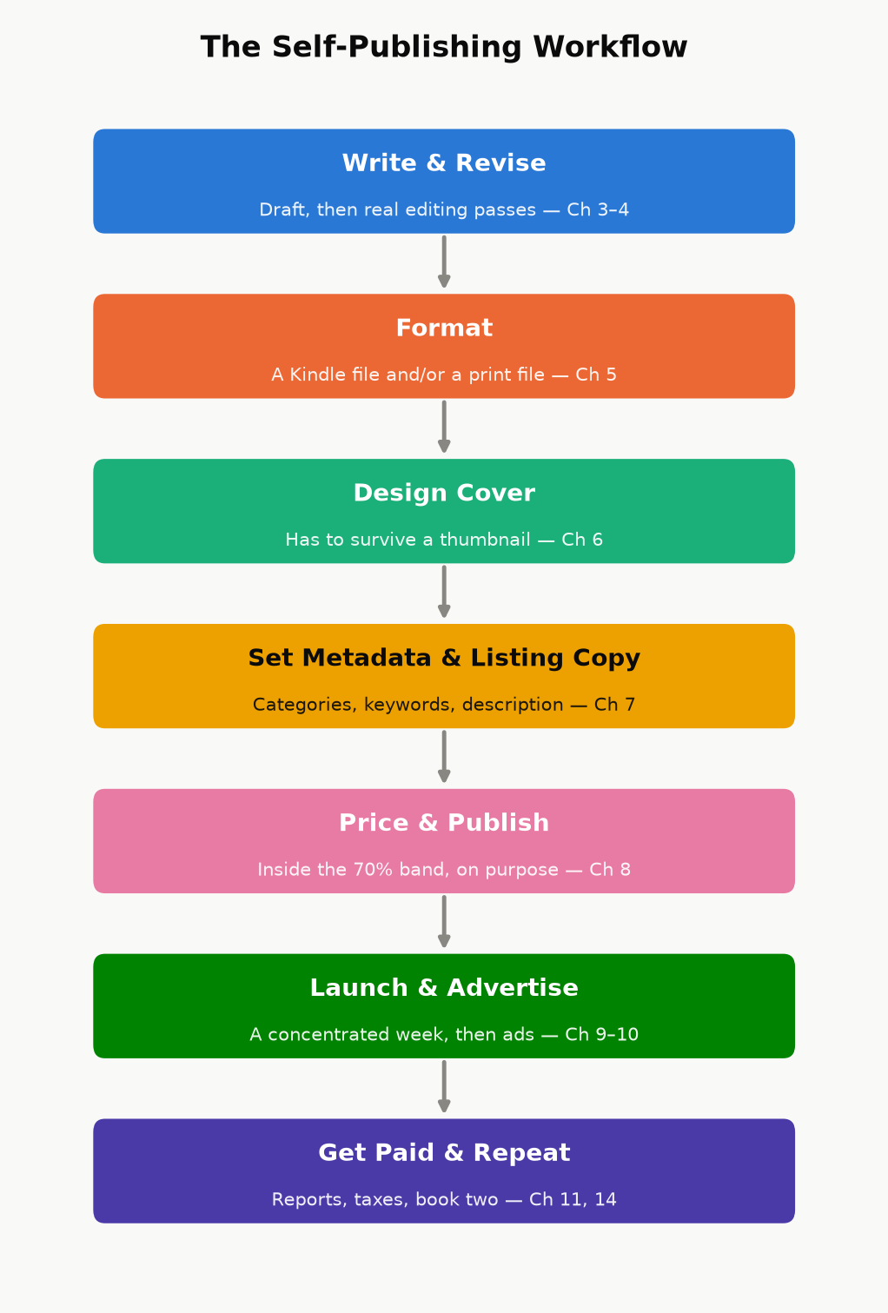
Figure 1.1 — The self-publishing workflow this book walks through, one chapter at a time. Nothing here is optional; skipping a stage just means finding out about it later, from a review or a royalty report instead of from this book.

A note on doing both
These paths aren’t mutually exclusive across a career, or even across a single book — some authors self-publish a series to prove it sells, then use that sales data to land a traditional deal for future volumes; others go the other direction, getting rights reverted on an out-of-print traditionally published backlist title and re-publishing it themselves. Nothing in this book requires you to pick a side forever. It requires only that, for the books you do self-publish, you treat the business side with the same care you’d want from a publisher you were paying to do it for you.

Chapter 2: How Amazon Actually Pays You
Before categories, before keywords, before a single dollar of advertising — you need to know what a sale is actually worth to you, in real currency, after Amazon’s cut and its fees. Almost every downstream decision in this book (what to price the book, whether an ad is profitable, whether Kindle Unlimited is worth joining) is a variation on the arithmetic in this chapter. Get this part wrong and every later chapter inherits the error.

The ebook royalty: two plans, one cliff
KDP offers two ebook royalty plans, and — this trips up a lot of new authors — which one you get is determined automatically by your list price, not chosen as a marketing strategy:
- 70% royalty, available when your list price falls within the plan’s price band for that marketplace (as of this writing, $2.99–$9.99 in the US store, with corresponding bands in other currencies), minus a delivery fee based on the file’s size — historically about $0.15 per megabyte. This plan also carries a “don’t undercut yourself” rule: KDP can decline the 70% rate if you’re offering the same book for less somewhere else.
- 35% royalty, available at any price from $0.99 up to $200, with no delivery fee subtracted. This is the only plan available outside the 70% price band — price a book at $1.99 or $12.99 and you’re on 35% automatically, whether you meant to be or not.
That’s the cliff: price one cent outside the 70% band and your royalty rate doesn’t taper, it drops by half. A worked example makes the stakes concrete.
Worked example. A 350-page ebook, roughly 1.2 MB as an EPUB, priced at $4.99:
- At 70%: $4.99 × 0.70 = $3.493, minus a delivery fee of roughly 1.2 MB × $0.15 ≈ $0.18. Net royalty ≈ $3.31 per copy.
- At 35% (say the author instead priced it at $2.49, just under the band): $2.49 × 0.35 = $0.87 per copy — with no delivery fee to subtract, but also less than a third of the higher price’s payout.
Pricing $2.50 lower cost this author roughly $2.44 per sale, not $0.87. That gap is the whole reason Chapter 8 spends as much time on pricing psychology as it does — the 70% band isn’t a suggestion, it’s where almost every nonfiction ebook in this genre should live unless there’s a specific reason not to.
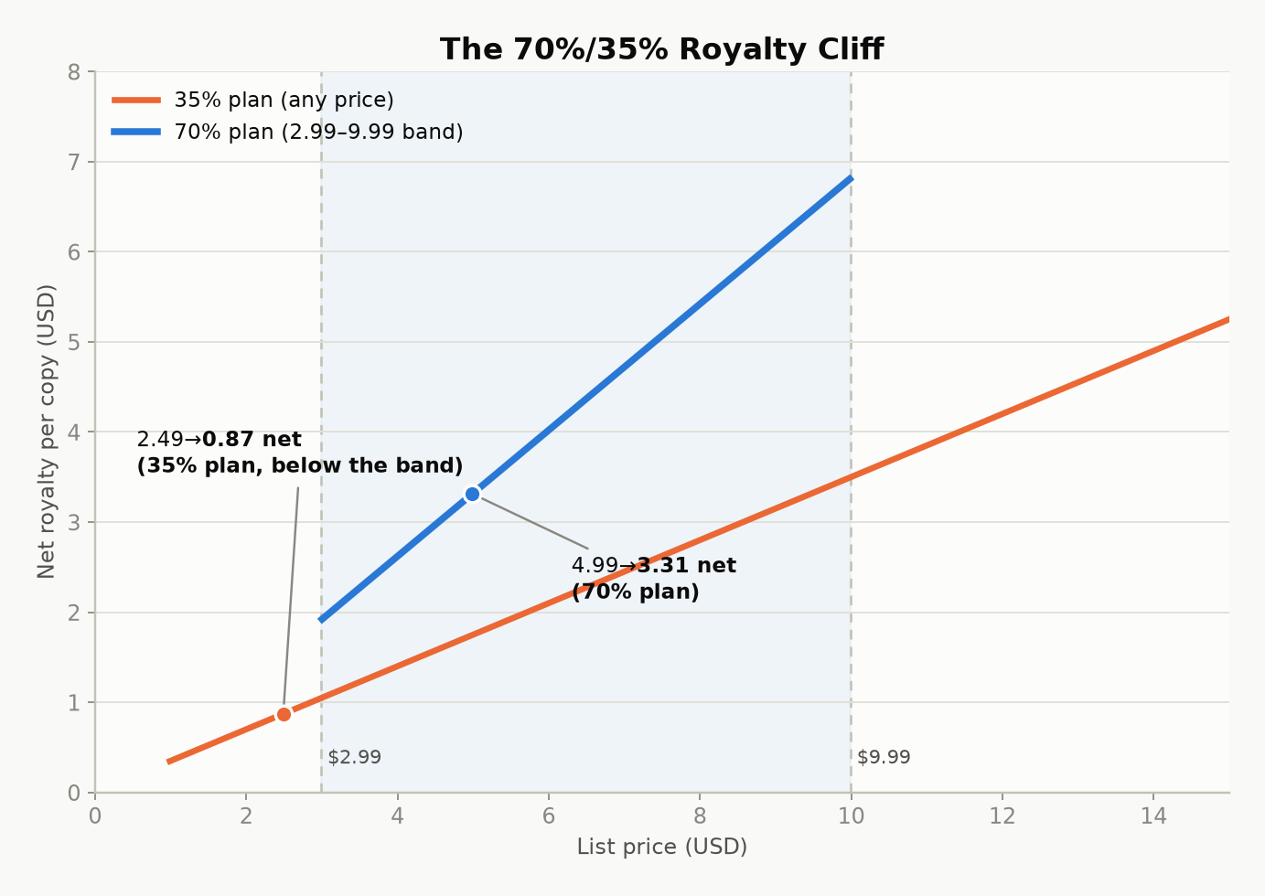
Figure 2.1 — Net author royalty per copy at each price point. The step at $2.99 and the ceiling at $9.99 are the 70%-plan boundaries; everything outside that band falls back to the flat 35% line.

Kindle Unlimited and the page-read fund
If you enroll a book in KDP Select (Chapter 12 covers the exclusivity trade-off that comes with it), it becomes available to Kindle Unlimited and Kindle Owners’ Lending Library subscribers, and you’re paid not a royalty per “sale” but a per-page rate out of a shared monthly fund — Amazon sets aside a pool of money each month and divides it by the total normalized pages read across all Select books. The per-page rate therefore moves slightly every month; it has historically sat in the range of roughly $0.004–$0.005 per page (KDP announces the exact figure after each month closes, in your Reports dashboard). Pages are counted using Amazon’s own KENPC (Kindle Edition Normalized Page Count) standard, not your Word document’s page count, so formatting choices — font embedding, image sizing, front-matter bloat — can shift your page count even though the words didn’t change.
Worked example. A 300-KENPC-page book fully read by one subscriber, in a month where the fund pays $0.0045/page: 300 × $0.0045 = $1.35 for that one full read — comparable to, sometimes less than, a single 70%-royalty sale, but earned from a reader who might never have paid $4.99 up front. Whether that trade is good for your book is exactly the question Chapter 12 answers.

Print: paperback and hardcover
Print royalties don’t use a percentage-of-price plan the way ebooks do; they use a formula:
Royalty = (List Price × Royalty Rate) − Printing Cost
- Paperback, sold through Amazon’s own store: 60% royalty rate.
- Paperback through expanded distribution (third-party retailers, bookstores, and libraries KDP can place the book with beyond Amazon itself): 40% royalty rate — the same list price, a smaller share, and worth checking on a book-by-book basis whether it’s worth opting into.
- Hardcover: also a 60% royalty rate minus printing cost, sold through Amazon’s own store.
Printing cost is not a number you pick — KDP calculates it from page count, trim size, ink type (black-and-white vs. color interior), and paper choice (standard white vs. cream), and it recalculates automatically if you change any of those. Use KDP’s own price calculator when you’re setting a print list price; don’t estimate the printing cost by hand, and don’t set a list price without checking that royalty ends up positive — it’s possible to price a heavily illustrated color paperback so low that KDP’s own calculator shows a negative or near-zero royalty at that price.
Key takeaway: A royalty rate is not a profit margin. It’s the number Amazon subtracts its own costs from — delivery fees for ebooks, printing costs for paperback and hardcover. Your actual per-copy profit is always smaller than the headline percentage, and every pricing decision later in this book starts from the real number, not the advertised one.

Reading your own numbers
Everything above is policy, which changes; your KDP Reports dashboard is fact, which doesn’t. Once a book is live, check the Sales Dashboard for units and estimated royalties in near-real time, and the Prior Months’ Royalties report once a month closes for the exact, finalized figures (including that month’s KENP rate). Get in the habit of reading it weekly during a launch and monthly afterward — it’s the only source in this entire book that’s about your book specifically rather than the platform in general, and every other chapter’s advice should eventually show up as a change in these numbers.

Part II — Writing and Producing the Book

Chapter 3: Choosing What to Write
“Write the book only you can write” is lovely advice and a poor business plan on its own. The books that make good money on Amazon sit at the intersection of two circles: something you can actually write well, and something a large enough group of people are already actively trying to buy. This chapter is about finding that intersection using Amazon’s own storefront as a research tool, instead of guessing.

Amazon is a market-research tool you already have access to
You do not need paid keyword-research software to start. Amazon shows you demand directly, if you know where to look:
- Browse the category you’re considering (not just the top-level genre — drill into the specific subcategory) and look at the current Best Sellers and Hot New Releases lists, not just the all-time top 100. All-time lists are survivorship-biased: they show you what won years ago, not what’s selling now. Hot New Releases shows recent books that are already gaining traction — a much better signal of live demand.
- Check review count relative to publication date. A book with 4,000 reviews published eight years ago tells you the category has (or had) demand; a book with 300 reviews published four months ago tells you demand exists right now and a new entrant can still compete for it.
- Look at who’s publishing in the category. A subcategory dominated by three or four publishers with decades of backlist is a hard room to enter. A subcategory full of single-book authors and recent, thin catalogs is fragmented — easier to be noticed in, though sometimes fragmented because the actual demand is smaller than it looks.
- Read the one- and two-star reviews on the current bestsellers in your topic, not the five-star ones. Five-star reviews tell you the book worked; one- and two-star reviews tell you exactly what it left out, explained by someone who wanted it to be there. That gap is your outline.

Write to a shelf, not into a void
Publishers call this “writing to a shelf” — knowing, before you write a word, which existing shelf your book would sit on, and what a reader browsing that shelf already expects. It sounds like it constrains creativity; in practice it’s the opposite of chasing a trend. Trend-chasing means noticing something is popular this month and racing to publish before the wave passes — by the time a trend is visible on Amazon’s charts, a meaningful number of other authors have already seen it too, and the category fills up fast. Writing to a shelf means picking a category with durable, structural demand (a persistent problem, a persistent hobby, a persistent stage of life) and writing the best specific answer to a specific reader’s specific question, rather than the broadest possible book that vaguely covers a popular topic.
Key takeaway: “Broad audience” and “big audience” are not the same thing. A book explicitly written for one clearly defined reader — a specific skill level, a specific goal, a specific constraint — usually outsells a book written to appeal to everyone, because the specific book’s cover, title, and sample pages all signal “this is for you” to the reader who actually needs it, instead of asking a general browser to self-select from vague language.

Standalone economics vs. series economics
A standalone book earns once per reader. A series earns on read-through — a reader who finishes book one and buys book two, three, four without any new marketing spend from you at all, because Amazon’s own “customers who bought this also bought” and “next in series” placements do the selling. This is the single biggest lever available to a self-published author with a limited budget: a five-book series with modest per-book sales and strong read-through routinely outearns a single book that sold as many total copies, because the series compounds — every new reader of book one is a prospective buyer of the other four, indefinitely, with no additional ad spend required. This applies to nonfiction too: a “beginner,” “intermediate,” and “advanced” set on the same topic, or a set of books that each solve one piece of a larger problem, gets the same compounding effect fiction series get from cliffhangers.
None of this is a substitute for writing something good. It’s the difference between writing something good into a category with active buyers and writing something equally good into a category nobody is currently searching. Both take the same effort to write; only one reliably gets found.

Chapter 4: From Draft to Manuscript
A finished draft and a finished manuscript are not the same object, and the gap between them is where most self-published books lose readers — not at the idea stage, and not usually at the sentence-craft stage, but in the unglamorous work of catching the errors, gaps, and inconsistencies that a single read-through by the person who wrote it will never catch, because that person already knows what they meant to say.

The passes, in order
- Developmental — is the structure right? Does the argument (nonfiction) or the plot (fiction) actually hold together, in the right order, with nothing important missing and nothing redundant?
- Line edit — does each paragraph read well? Is the voice consistent? Are explanations at the right level for the stated audience?
- Copyedit — grammar, consistency (character names, spelled-out numbers vs. numerals, capitalization rules, a style choice applied the same way everywhere), and fact-checking any claim a reader could look up and check.
- Proofread — the final pass, done on the manuscript in its near-final formatted state, catching typos, double spaces, and formatting accidents introduced by the editing process itself.
These are genuinely different skills, and treating them as one pass — “I’ll just read it again” — is the most common reason a self-edited book feels “almost professional” instead of professional. If you can only afford to hire one of these out, hire the copyedit; it catches the errors a reader notices consciously (“that’s a typo”) rather than the ones they only feel (“something about this felt amateur”).
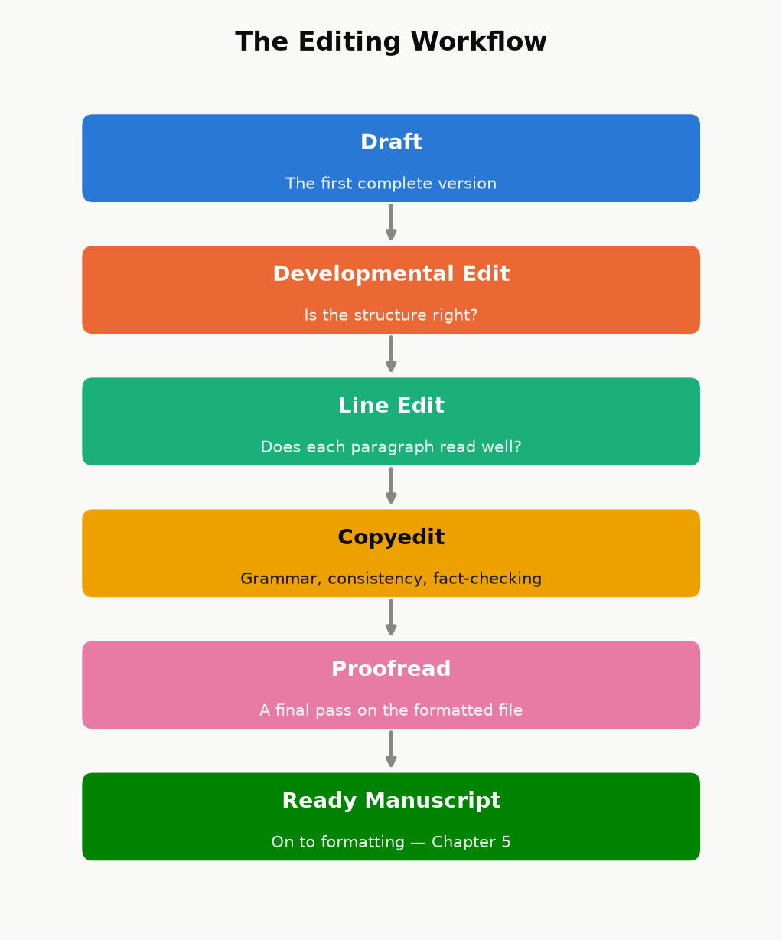
Figure 4.1 — Four genuinely different passes, run in order, ending in a manuscript that’s actually ready for Chapter 5 — not four names for the same read-through.
Case study: what “professional-grade” editing actually looks like in practice. Elsewhere in this same catalog, a 38-chapter technical book went through three separate independent review passes after its first “complete” draft — each one specifically briefed to hunt for what the previous pass missed rather than re-check settled items, each one independently re-deriving every worked numerical example from scratch rather than trusting the displayed answer. The three passes together found and fixed 13, then 21, then 18 confirmed issues — genuine arithmetic errors, a physics claim that quietly contradicted the book’s own formula two paragraphs earlier, cross-references pointing at the wrong chapter after a renumbering, and (twice) a fix from an earlier pass that had itself introduced a new, smaller inconsistency. A companion book in the same catalog ran a dedicated mechanical sweep for overused qualifier words — “roughly,” “essentially,” “itself” — appearing twice on the same page, catching 111 instances a normal read-through had sailed past every time, because a reader’s eye and a targeted script are looking for different things. The lesson isn’t “hire three editors” if your budget doesn’t allow it — it’s that the errors still in your manuscript after one careful read are, almost by definition, the ones a normal read doesn’t catch. Budget at least one pass that is specifically not just reading the book again: a fact-check pass, a consistency script, a reader who has never seen the manuscript before.

Where AI genuinely helps, and where the line is
Used well, AI tools can speed up the unglamorous parts of this process: a first-pass consistency check across hundreds of pages, generating several alternative phrasings of an awkward paragraph for you to choose between and rewrite, condensing research notes, or catching a subset of the kind of mechanical errors described above. Used badly, it becomes the entire book — a prompt, minimal human review, and a KDP upload — and readers have gotten noticeably better at spotting the tell-tale flatness of that approach, which shows up in review sections as a specific and damaging complaint.
Two things are not optional, regardless of how much AI assistance you use in your process:
- Amazon requires disclosure. KDP’s publishing questionnaire asks you to declare whether a title contains AI-generated text, images, or translation, and misrepresenting that is a content-policy violation, not a gray area. Answer it honestly.
- A human has to be the last editorial judgment. Whatever tools condense, draft, or suggest, the decision that a sentence is accurate, that an example is correct, and that a chapter says what you actually mean has to be made by a person who is accountable for it — which in practice means the fact-check and consistency passes above are not optional just because a tool helped write the first draft.

A minimum revision checklist
If you do nothing else before publishing, do these:
- Read it aloud, or have text-to-speech read it to you. Your ear catches rhythm problems and repeated words your eye slides past.
- Check every number and every cross-reference. “As shown in Chapter 4” needs to actually be Chapter 4, still, after every reorganization.
- Run one adversarial pass. Read it once specifically looking for ways to be wrong — a claim you can’t actually back up, a promise the book doesn’t deliver on, a contradiction between an early chapter and a later one.
- Get at least one outside reader who has never seen the manuscript before, and ask them specifically where they got confused or bored, not just whether they “liked it.”

Chapter 5: Formatting That Doesn’t Break Kindle
Ebook formatting and print formatting are not the same job wearing two hats — they solve different problems, and treating one file as automatically correct for both formats is where a lot of self-published books develop avoidable, embarrassing bugs (a page-number reference in a book with no fixed pages, a table of contents with no working links, a paperback with no page numbers at all).

Ebooks: let Kindle do the navigation
A Kindle reader can change font size, font, and line spacing, which means your ebook has no fixed pages — “page 47” means something different on every device and at every font size a reader might choose. Two consequences follow directly:
- Don’t build a page-numbered table of contents. It cannot be accurate, because there are no fixed pages to number. Kindle instead builds its own “Go To” navigation menu automatically, directly from your document’s Heading 1 / Heading 2 paragraph styles — which is why using real heading styles (not just bold, oversized text that merely looks like a heading) is the single most important formatting choice in the whole manuscript. A plain-text contents listing (titles only, no page numbers, the way this book’s own front matter does it) is a nice reader convenience on top of that, not a replacement for it.
- Skip the index. A print index maps terms to page numbers; without fixed pages, that mapping is meaningless. If a reference title needs a true, searchable index, that’s a signal to route it through print rather than positioning it as a Kindle-only reference work.
Beyond headings, keep ebook formatting deliberately plain: standard paragraph styles, images sized to look correct at typical device widths rather than at one specific screen size, and no fixed-width text boxes or multi-column layouts, which most reflowable Kindle formats handle poorly. Kindle Create (Amazon’s free formatting tool) or a clean Word document with correctly applied heading styles both get you there; what matters is the underlying structure, not which tool produced it. Before you publish, use KDP’s own online previewer and check the book on more than one simulated device size — a layout that looks fine on a tablet-width preview can crowd an image awkwardly on a phone-width one.

Print: everything the ebook didn’t need
A paperback or hardcover interior needs the things the ebook explicitly skipped, plus a few of its own:
- A real, page-numbered table of contents — because print pages are fixed, this one actually works, and readers expect it.
- Page numbers and (usually) running headers, placed and styled consistently throughout.
- Front matter in the conventional order: title page, copyright page, optional dedication, table of contents, then the body — readers of print nonfiction expect this shape, and deviating from it reads as amateur even when nothing is technically wrong.
- A trim size choice. 6”×9” is the most common choice for nonfiction — large enough to keep line lengths comfortable, small enough to print economically — with 5.5”×8.5” a common alternative for shorter, more portable guides.
- Margins that account for the gutter — the inner margin needs extra room so text isn’t swallowed by the binding, especially as page count grows.
- Bleed, only if something touches the page edge. A book with no full-bleed images or background color doesn’t need a bleed margin at all; add one only for pages that actually require it.
- Spine width and cover dimensions calculated by KDP’s own cover template tool, not by hand. Spine width depends on exact page count, trim size, paper color (white vs. cream), and interior ink (black-and-white vs. color) — four variables that make hand-calculating it a good way to order a cover that doesn’t fit.
- A physical proof, ordered and actually read, before you hit publish. Screen previews miss things — color that renders differently in print, a margin that looked fine on screen but crowds the gutter, a font substitution — that only show up in your hands.
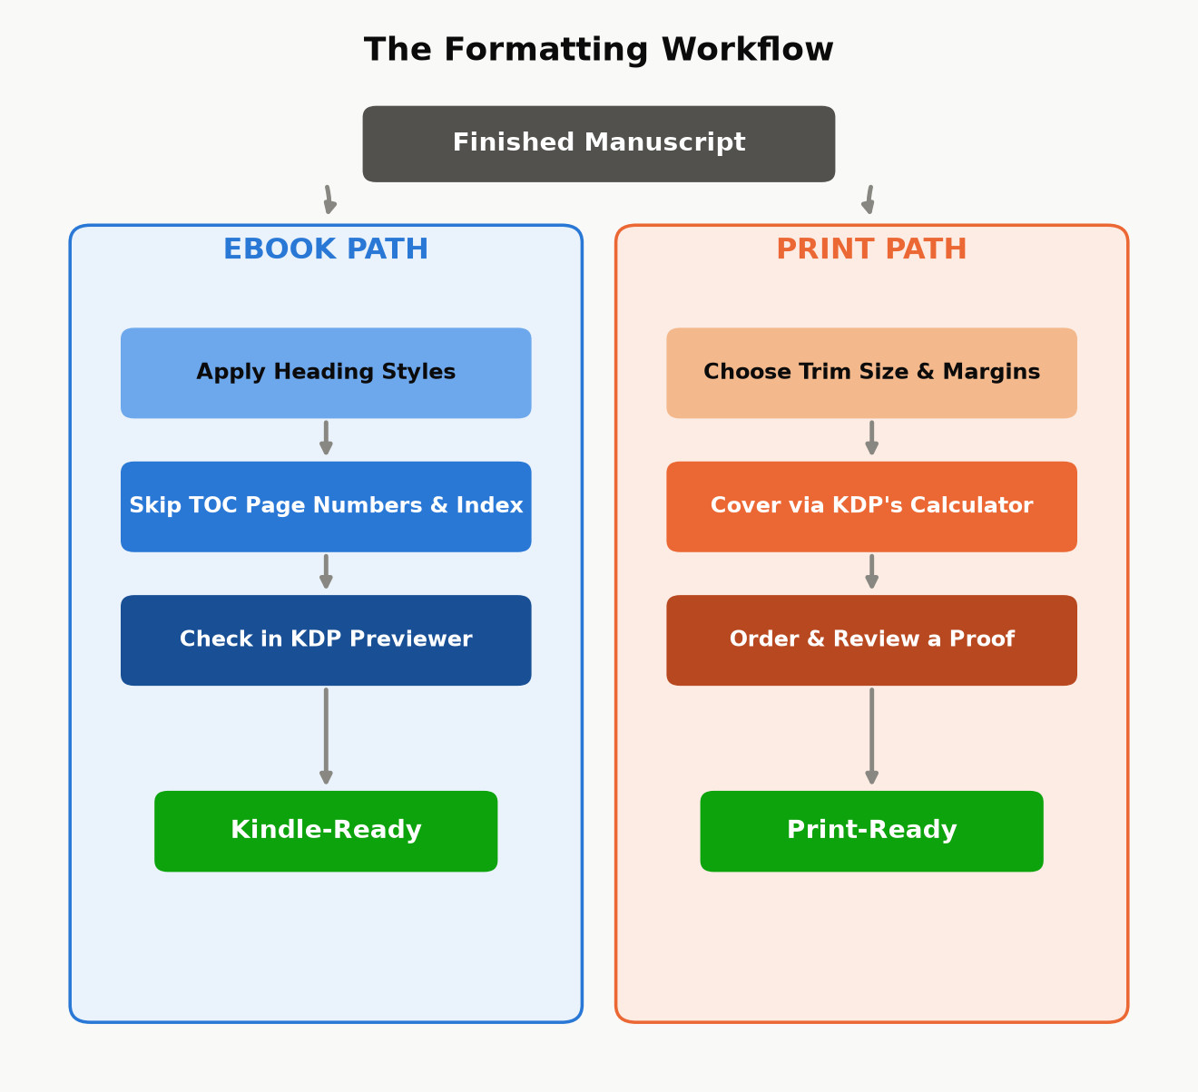
Figure 5.1 — The same finished manuscript, two different finishing workflows. They diverge immediately, and “did the ebook steps by habit on the print file” (or vice versa) is exactly the kind of avoidable bug this split is meant to prevent.
Key takeaway: Format for the reader’s actual device, not for how the manuscript looks in your word processor. An ebook formatted like a Word printout (fixed page-number references, a dead table of contents) looks broken to a Kindle reader; a paperback formatted like a webpage (no page numbers, no running headers) looks unfinished to a print reader. Same words, two different finished products.

Chapter 6: Covers That Sell in a Thumbnail
A cover has one job before it has any other job: survive being shown at roughly the size of a postage stamp. Almost every place a shopper actually encounters your book for the first time — search results, a “customers also bought” carousel, a category browse grid — shows it small, often under 150 pixels wide, often on a phone screen, often for under a second before the shopper’s eye moves on. A cover that looks stunning full-screen and unreadable as a thumbnail has failed at its actual job, no matter how good the artwork is.

The thumbnail test
Before you finalize any cover — yours or a hired designer’s — shrink it down to actual thumbnail size and look at it from a normal viewing distance, not zoomed in on your monitor. Ask three questions:
- Can you read the title at that size, at a glance, without leaning in?
- Does the genre or category read correctly at a glance — does a business book look like a business book, a thriller like a thriller — even with no ability to read the small print?
- Is there one clear focal point, or does the eye not know where to land?
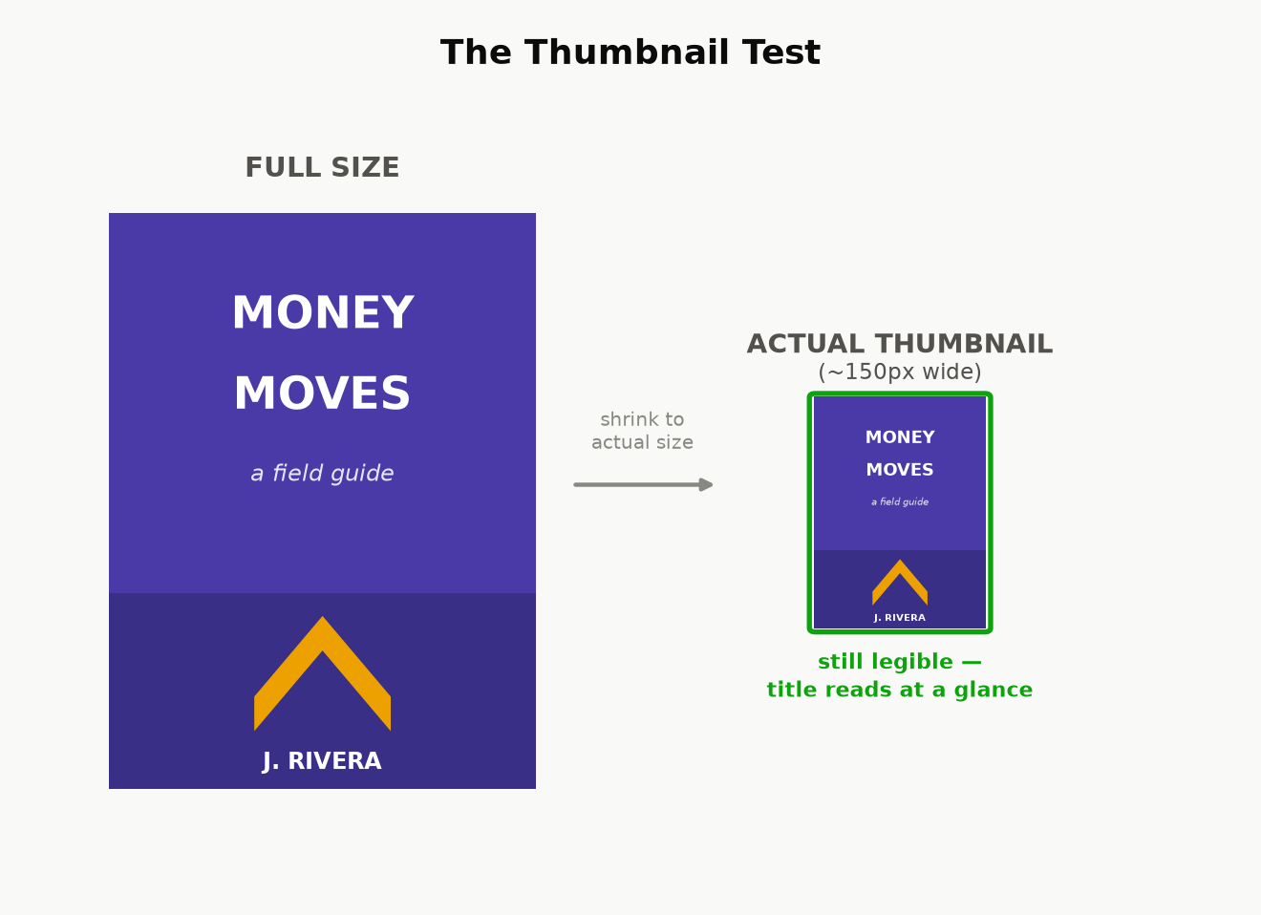
Figure 6.1 — The same cover concept at full size and at the size a shopper actually sees it first. Details that read fine large enough often disappear entirely at thumbnail size — check at the smaller size, not the larger one.

Genre conventions exist because readers use them
A reader scanning a category page is pattern-matching, not reading — they’ve learned, from years of browsing, what a thriller cover looks like versus a cozy mystery, what a business book looks like versus a memoir. This isn’t a creative constraint to fight; it’s a communication channel to use. A cover that deliberately breaks convention can work, but only as a calculated choice made after you understand what you’re breaking from — breaking convention by accident, because you didn’t research what similar, successful books in your exact category actually look like, just reads as confusing rather than distinctive. Before commissioning or designing a cover, pull up the current bestsellers in your specific subcategory and note what they share: color palette conventions, typography weight, how much of the cover is imagery versus type, where the author name sits relative to the title.

Hierarchy: title, subtitle, author — in that order, usually
For most nonfiction, the reading order a cover should guide the eye through is: title first (the hook), subtitle second (the specific promise — for nonfiction, the subtitle is doing real advertising copy work, not just decoration; it’s where “learn to play piano” becomes “learn to play piano in 30 days with no prior experience”), author name last, unless you’re already a known quantity in the category, in which case your name can carry as much weight as the title. Don’t split attention evenly across all three — a cover where the title, subtitle, and author name are all the same visual weight gives the eye nowhere obvious to start.

DIY, template, or hire — and what each actually costs
- KDP’s built-in Cover Creator produces a serviceable, template-based cover for free. It is recognizable as a template to anyone who’s seen a few of them, which is a real cost even though the dollar cost is zero — fine for testing an idea, rarely the right choice for a book you’re investing real marketing effort behind.
- Template marketplaces and freelance platforms (pre-made cover templates customized with your title, or a freelancer working from a brief) typically run from double digits to a few hundred dollars and can look genuinely professional if you choose a template built for your actual genre and category, not just one that looks nice in isolation.
- A dedicated cover designer, especially one who already works in your specific category, costs more — often several hundred dollars and up — but understands the genre conventions above without being told, and is usually the best return on investment for a book you expect to actively market, because the cover is one of the few assets that keeps working for you on every single impression, for free, for as long as the book is listed.
Whichever route you take, run the finished cover through the thumbnail test above before you commit to it — it’s the cheapest quality check in this entire chapter, and the one most often skipped.

Part III — Getting Discovered

Chapter 7: Categories, Keywords, and Your Product Page
A shopper finds your book two ways: searching for it directly, or browsing a category and encountering it. Keywords control the first path, categories control the second, and both are set from the same KDP upload screen in about five minutes — which is exactly why they’re worth doing carefully instead of on autopilot. This is the cheapest, highest-leverage discoverability work in the entire book, because it costs nothing and takes effect immediately.

The seven keyword slots
KDP gives you seven keyword fields, each accepting a phrase of up to fifty characters. Three rules make the difference between slots that work and slots that are quietly wasted:
- Use full phrases, not single words. A slot can hold “budgeting for freelancers with irregular income,” not just “budgeting” — and a specific phrase matches how people actually type search queries far better than any single generic word does. A single word also wastes the other forty-plus characters of space you were given.
- Don’t repeat words already in your title, subtitle, or series name. Amazon already indexes those for search; a keyword slot spent repeating “budgeting” when your title already contains “budgeting” is a slot doing no new work at all. Spend every slot on a phrase your title doesn’t already cover.
- Never use another author’s name, a competing book’s title, or a trademarked term you don’t own, even though it’s technically possible to type one into the field. This is a KDP content-policy violation, not a gray-area growth hack, and it risks the listing itself, not just the keyword.
Where do the actual phrases come from? The single best free source is Amazon’s own search bar: start typing a query a real customer might type — “how to self-publish,” “self-publishing for” — and read the autocomplete suggestions. Those are real, aggregated queries other shoppers have actually typed, which makes them a far better source than guessing. Reading the “Look Inside” blurb language and the customer-review wording on the current bestsellers in your category is a second free source — readers often describe a book using different words than the author chose for the title, and those reader words are exactly what future readers will search.
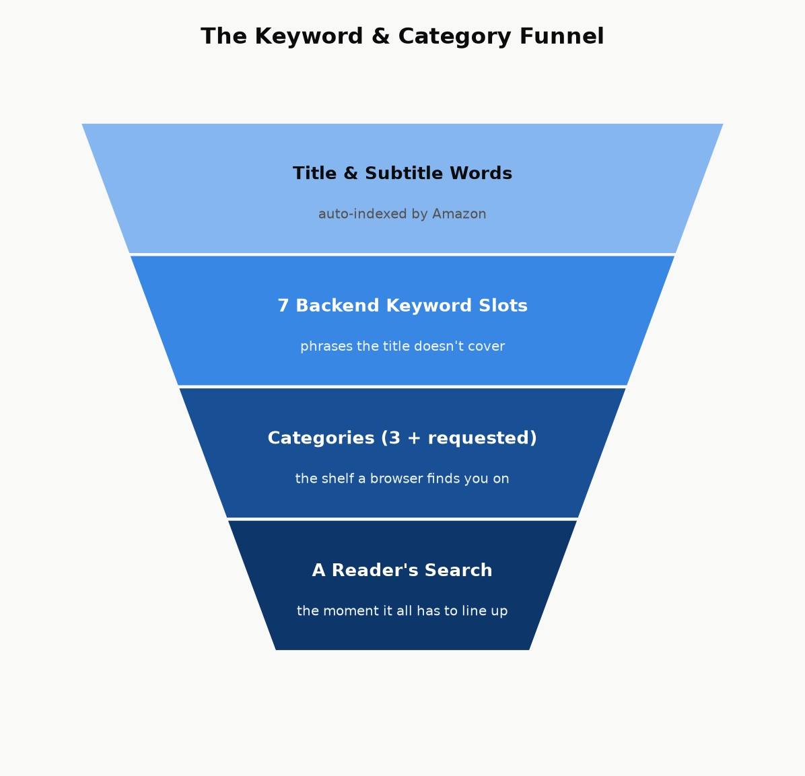
Figure 7.1 — Discovery is a funnel: your title and subtitle are indexed automatically, seven backend keyword slots extend that coverage to phrases the title doesn’t use, categories place you on the right shelf, and all of it only pays off if it matches what a real shopper actually types or browses for.

Categories: pick the smallest room you actually belong in
At upload, KDP lets you choose up to three browse categories from Amazon’s BISAC-based category tree. The instinct to pick the biggest, most prominent category (“Business & Money”) is usually a mistake — it’s an enormous room where you’re competing against every business book on Amazon for attention. The more specific leaf category you can honestly claim (“Business & Money → Small Business & Entrepreneurship → Home-Based Businesses,” for instance) is a much smaller room, which means a given level of sales velocity moves you much further up its charts — including, for a genuinely small category, potentially far enough to earn an “#1 Best Seller” orange tag, which is itself a credibility signal that helps convert future browsers.
Amazon’s full category list is considerably longer than the categories exposed in KDP’s own self-service picker. If you find categories in Amazon’s published category list that fit your book better than anything in the picker, you can request them directly: contact KDP support through your bookshelf (Contact Us → the appropriate content or metadata topic) and give them the exact category paths, taken from Amazon’s official category list, that you want added. This is a real, ordinary support request, not a workaround — support staff add categories manually all the time when an author identifies a better-fitting one that the upload picker doesn’t surface.
Key takeaway: Both categories and keywords are free, instant, and editable — you can revisit them the day after launch based on how the book is actually performing. Set them thoughtfully at launch, but don’t treat the first choice as permanent; if a category isn’t producing visibility after a reasonable window, it costs nothing to request a better-fitting one.

Your product page: the description does the selling the cover can’t
The cover (Chapter 6) earns the click. The book description — the block of text on the product page, up to 4,000 characters, with light HTML formatting available (bold, italics, line breaks, bullet lists) through KDP’s description editor — is what turns that click into a sale. It is advertising copy, not a table of contents, and the single most common mistake is writing it like the second thing instead of the first.
The shape that works, in order:
- A hook, in one or two sentences. Open on the reader’s actual problem or the transformation they want, not on your book’s topic. “Most new authors lose money on their first book” earns another sentence of attention; “This book is about self-publishing on Amazon” does not.
- The promise. One short paragraph on what the book delivers and, for nonfiction specifically, why this author — credentials, results, or a specific angle that differentiates it from the ten other books on the same shelf.
- A scannable bulleted list of concrete takeaways. Most shoppers skim rather than read a product description top to bottom; five to eight specific, concrete bullets (“The exact royalty math behind the 70%/35% split,” not “Learn about royalties”) do more conversion work than another paragraph of prose.
- Proof, if you have it. A review pull-quote, a credential, a relevant result — this section is optional and short; don’t manufacture proof you don’t have.
- A short call to action. One line, telling the reader what happens next (“Scroll up and grab your copy” reads as a cliché for a reason — it works because it removes the last moment of friction before the buy button).
Worked example — before and after.
Before: “This book covers how to publish on Amazon KDP. It talks about royalties, pricing, categories, keywords, and marketing. It is useful for anyone who wants to become a self-published author.”
After: “Most new authors lose money on their first book — not because the book is bad, but because nobody told them how the royalty math, the categories, or the ads actually work. How to Publish and Make Good Money fixes that, with the arithmetic shown every time. Inside, you’ll learn: the exact price where your royalty rate cuts in half (and why most authors hit it by accident) · the seven keyword slots almost everyone wastes · a break-even ad formula you can run in your head · which KDP Select and going-wide decision actually fits your book. No guru pitch, no upsell — just the mechanics, shown, so you can run the numbers yourself.”
Same facts, same length limit — the difference is entirely in what got promoted to the first sentence and what got turned into something scannable instead of buried in a paragraph.
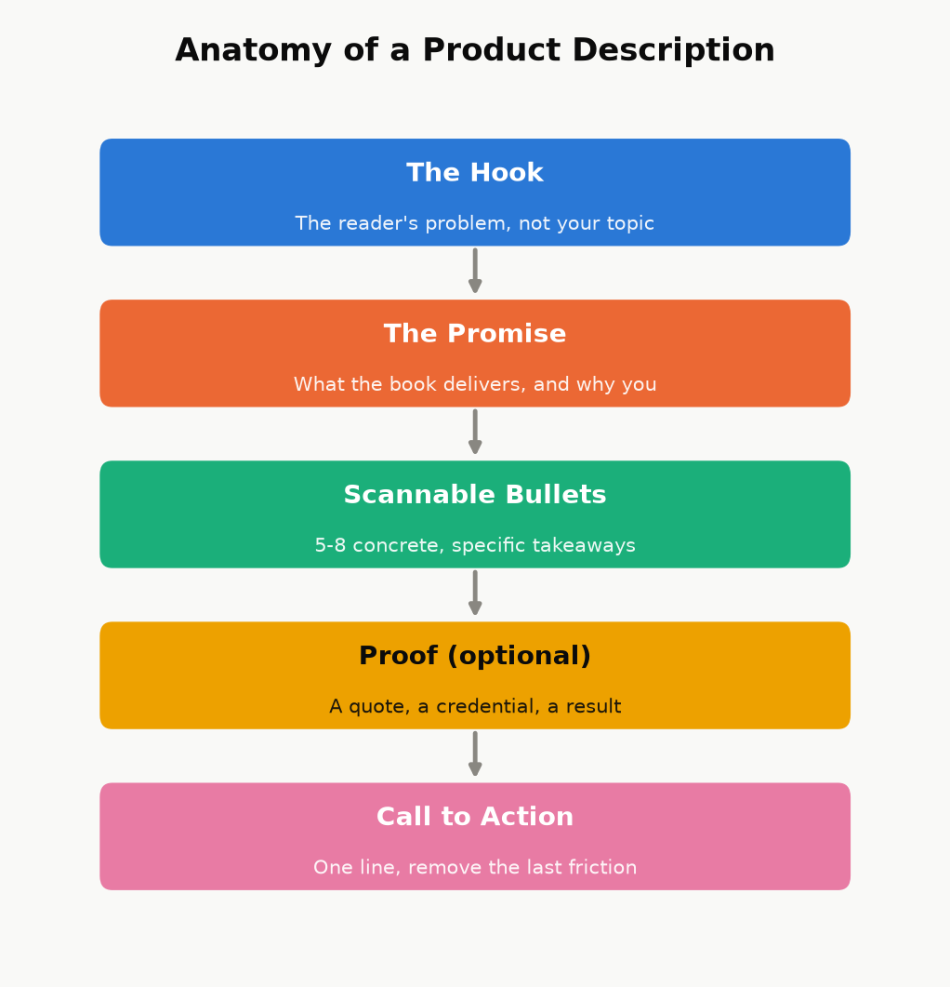
Figure 7.2 — The description’s job, in order. Skip the hook and open on your topic instead, and most shoppers never reach the part where you actually make your case.
Two more product-page pieces, both free and easy to skip:
- Amazon Author Central. A free profile — bio, photo, and every book you publish under that name, automatically linked — that turns a single-book sale into a chance to be discovered as an author with a catalog (Chapter 14). There’s no reason not to set this up on day one.
- A+ Content (Enhanced Brand Content). Image-and-text modules that can appear further down the product page. Eligibility and setup have changed more than once and vary by account, so treat this as “worth checking your current KDP dashboard for,” not as a guaranteed day-one option the way Author Central is.
Like price and keywords, the description isn’t a one-time decision — it’s editable the same afternoon you notice it isn’t converting, at zero cost. If a book has decent traffic (from ads or category placement) but a weak conversion rate, the description is one of the first three places to look, right alongside the cover and the price.

Chapter 8: Pricing for Profit
Chapter 2 showed you the mechanical cliff between the 35% and 70% royalty plans. This chapter is about where inside — or deliberately outside — that band your specific book should sit, and why “as high as the market will bear” and “as low as possible to win on price” are both usually wrong answers for a new nonfiction title.

The default range, and why
For most standalone nonfiction in the $2.99–$9.99 band, $3.99–$6.99 is a sensible starting range: high enough to signal real value (a $0.99 how-to guide reads, fairly or not, as slight and disposable to a lot of shoppers), low enough to be an easy impulse decision against a specific, felt problem. A narrow, high-authority professional or technical niche can often support pricing at or near the $9.99 ceiling of the 70% band — readers solving an expensive problem (a business decision, a certification, a skill tied directly to income) are reliably less price-sensitive than readers buying general-interest nonfiction, and testing a higher price within the band costs you nothing but a little time to observe the effect on conversion.
Pricing under $2.99 does double damage at once: it drops you to the 35% royalty plan (Chapter 2’s cliff) and it can read, to a browsing shopper, as a signal that the book itself is thin or low-effort — the opposite of the “impulse-buy bargain” effect a low price is often chosen to create. There are legitimate reasons to price low deliberately (a short lead-in title meant to build an email list or a series, discussed below) — but those are choices made for a specific strategic reason, not a default.
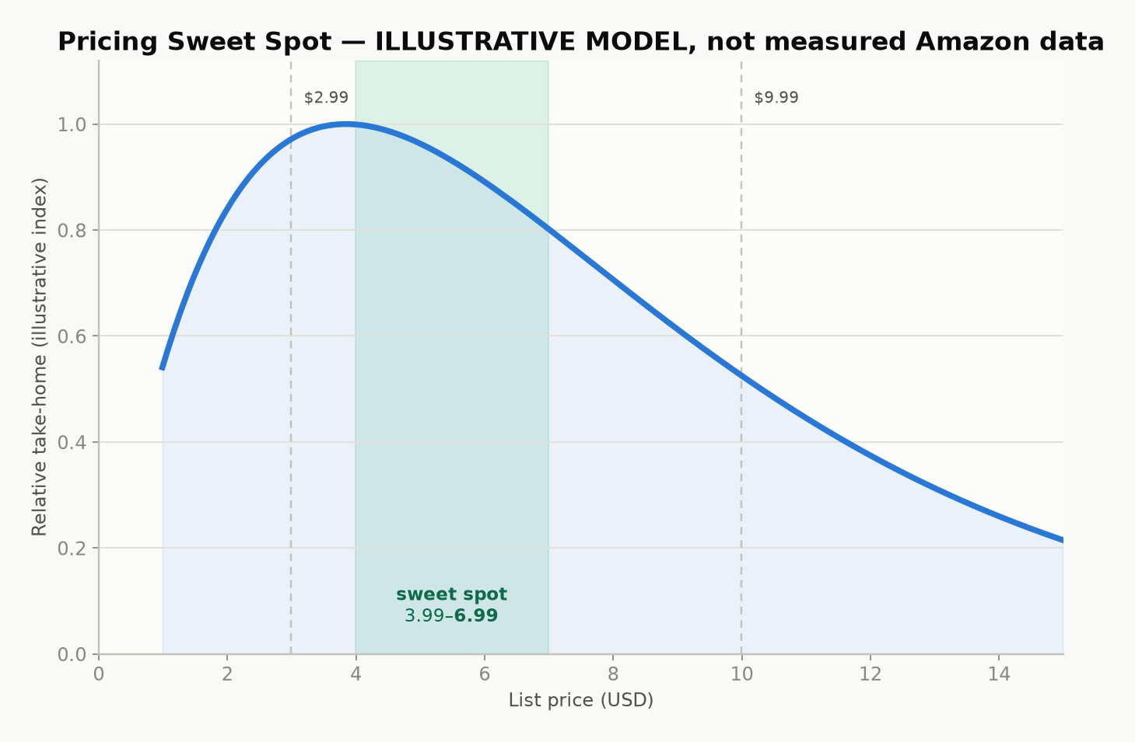
Figure 8.1 — Illustrative model, not a disclosed Amazon statistic: take-home per book is price times conversion, and conversion falls as price rises. The curve’s shape — a broad middle that beats both extremes — is the real lesson; the exact peak location varies by book, category, and audience.

Print has its own floor
A paperback or hardcover list price must clear the printing cost before any royalty exists at all (Chapter 2’s formula). KDP’s price calculator will show you the minimum list price at which a royalty becomes positive for your exact page count, trim size, and ink choice — treat that number as an absolute floor, not a target, since a print book priced at the bare minimum often leaves you earning a few cents a copy after printing cost, which covers approximately none of the time this book has described so far.

Pricing a series on purpose
For a series or a closely related set of nonfiction guides, price is a strategic lever across the whole set, not just one book: many authors price the first entry a little lower than the rest, specifically to lower the barrier to the read-through effect described in Chapter 3 — a reader who tries book one cheaply and likes it converts into a full-price buyer for every subsequent book, with no further marketing spend from you. True “$0.00 forever” pricing isn’t directly settable on KDP outside specific short promotional windows; the common way authors achieve a genuinely permanent free first-in-series title is by setting the ebook free on a retailer that allows it directly (Apple Books, or a distributor like Draft2Digital that reaches several at once — see Chapter 12), then submitting that lower price to Amazon as a price-match request, since Amazon’s own systems will match a lower verified price found elsewhere.

Discount tools, honestly described
KDP Select enrollment (Chapter 12) unlocks Free Book Promotions — a limited number of days where an enrolled book can be offered free directly on Amazon, useful for a launch push or to re-energize a backlist title’s visibility. Kindle Countdown Deals, a previous KDP Select discount tool, have since been discontinued — a reminder that this entire category of tool changes over time, and the right move before running any promotion is checking your KDP Select terms page for what’s currently actually offered, not relying on what an older blog post describes.

Chapter 9: Launching Without an Audience
The single biggest myth about a book launch is that it requires an existing audience. It doesn’t — it requires concentration: the same number of sales and reviews landing in a short, coordinated window does far more for a new book’s visibility than the identical numbers trickling in over a month, because Amazon’s own ranking and recommendation systems respond to velocity — how fast a book is moving right now — not just cumulative totals.

Pre-orders: a deadline you set for yourself
KDP lets you list a book for pre-order up to a year ahead of its release date, which gives you weeks or months to gather momentum before day one instead of starting cold. The trade-off is a real deadline: your final manuscript file has to be locked in and approved before the release date, and Amazon has tightened its enforcement around pre-orders that miss their promised release — a pattern of late files can cost an account its pre-order privileges entirely. If you use a pre-order, treat the file-upload deadline as immovable and finish your revision passes (Chapter 4) with real margin before it, not right up against it.

Building an ARC team, correctly
An ARC (Advance Reader Copy) team is a small group of readers who receive the book free, ahead of or right at launch, in exchange for an honest review. Recruiting one is straightforward — a call-out to your existing network, relevant online communities for your genre or topic, or a simple sign-up page — but the ethical and policy line here is sharp and worth stating plainly:
Key takeaway: You may give a book away free in exchange for a reader’s honest opinion. You may never give anything — a free copy, cash, a discount, or any other incentive — in exchange for a positive review, or review-swap with other authors. The first is normal, encouraged industry practice and is what an ARC team actually is. The second is a violation of both Amazon’s content policies and FTC disclosure rules, and it’s the exact mechanism behind several real account suspensions. Ask for honesty, not praise, and say so explicitly when you hand out review copies.

Launch week is a coordination problem, not a luck problem
The goal of launch week is to concentrate every review, every purchase from your own network, and any promotional push you’re running into the same narrow window — rather than let them land in a scattered trickle — because a short burst of real velocity is what triggers “Hot New Release” placement and meaningful category rank movement. Category rank is relative and constantly recalculated: it reflects your sales velocity compared to everything else currently active in that category, not a lifetime total, which is exactly why the specific, smaller category you chose in Chapter 7 matters so much at launch — the same burst of sales that barely dents a giant category’s chart can be enough to hit #1 New Release or #1 Best Seller in a well-chosen, narrower one, and that badge then becomes its own discoverability and credibility signal to every subsequent browser.
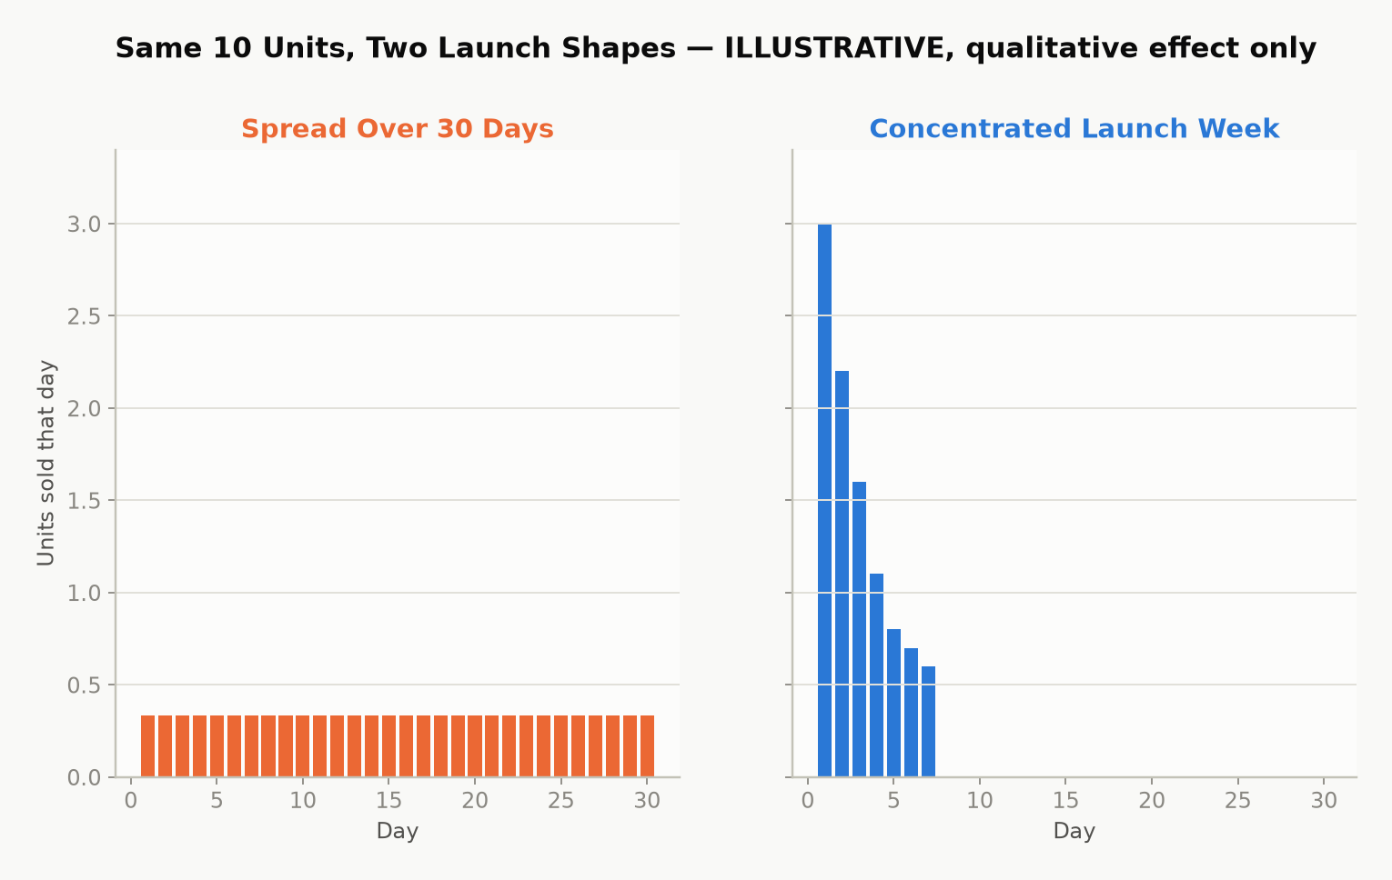
Figure 9.1 — Illustrative model: the same total sales, spread thin across a month versus concentrated into a launch week. Amazon’s own ranking mechanics aren’t public, but the qualitative effect — concentrated velocity moves rank further than the same total spread thin — is well established indie-publishing practice, not a guarantee for any specific book.
A practical launch-week checklist: line up your ARC reviews to post at or immediately after launch rather than whenever each reader happens to finish; tell your own network the specific date rather than “it’s out now” whenever convenient; and hold back any planned ad spend or promotion (Chapter 10) to start the same day rather than staggering it in afterward.

Chapter 10: Amazon Ads Without Wasting Money
Amazon Advertising (Sponsored Products, for most authors) lets you pay to place your book directly in search results and on other books’ product pages. It’s the closest thing self-publishing has to a dial you can turn up or down on demand — and also the fastest way to lose money if you turn it on without understanding the one number that actually matters: whether an ad is profitable at all.

Auto campaigns first, manual campaigns second
Start with an automatic targeting campaign, where Amazon chooses which searches and product pages to show your ad against based on your book’s own metadata. Its job isn’t to be profitable on day one — it’s to generate data: after a couple of weeks, its Search Term Report shows you exactly which real customer searches actually led to clicks and sales. Take the phrases that converted well and move them into a manual campaign, where you control the bid on each keyword directly, and let the underperforming broad automatic spend taper down. This sequence — auto for discovery, manual for control — avoids the common new-advertiser mistake of guessing at keywords from scratch and bidding blind.
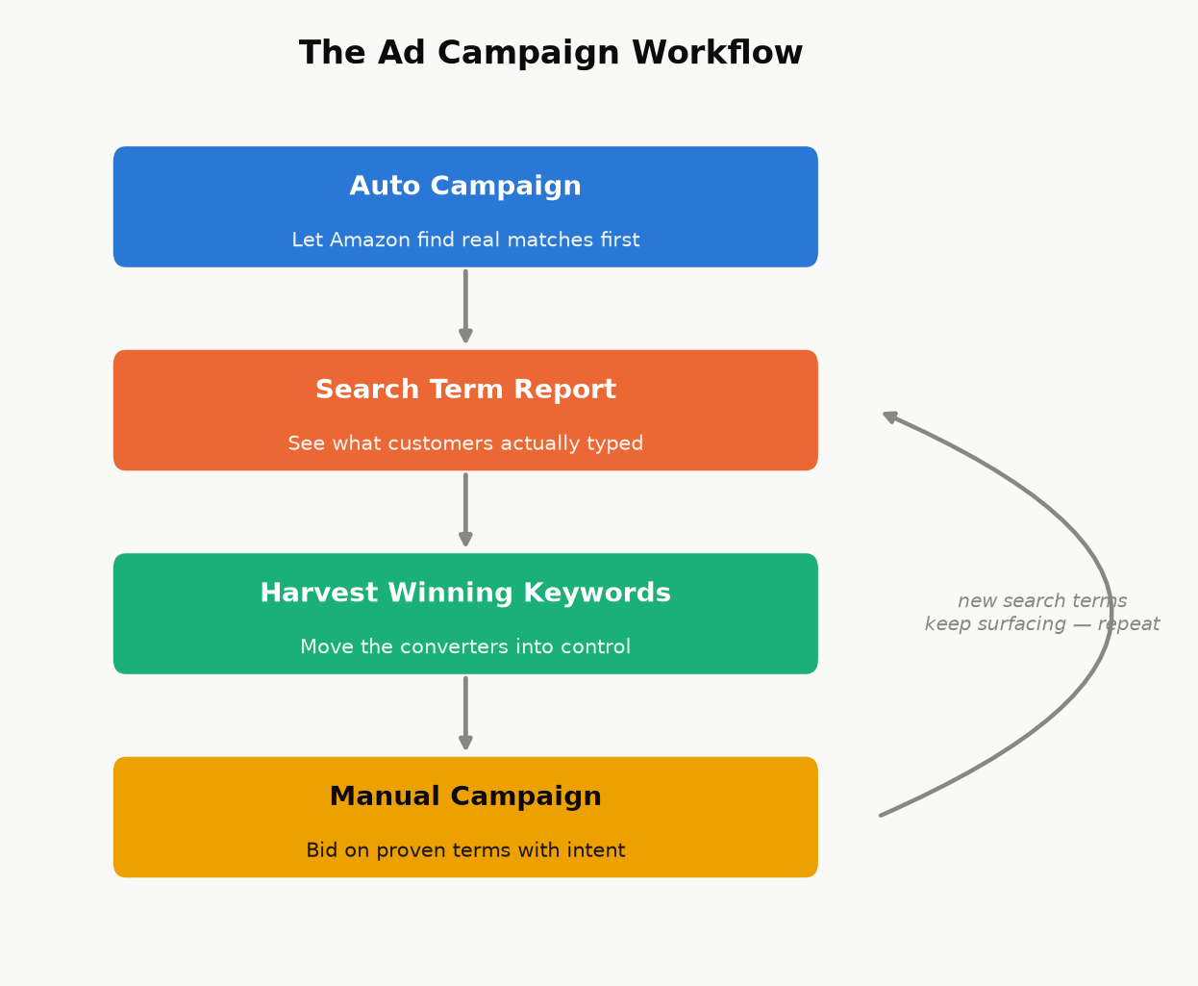
Figure 10.1 — This isn’t a one-time setup. New search terms keep surfacing after the first harvest, so the loop back to the Search Term Report keeps running for as long as the campaign does.

The only formula that matters: break-even ACOS
ACOS (Advertising Cost of Sales) is simply:
ACOS = Ad Spend ÷ Ad-Attributed Sales × 100%
An ad is profitable exactly when its ACOS is below your break-even ACOS — the percentage of a sale’s revenue that equals your actual royalty margin:
Break-even ACOS ≈ Royalty per Copy ÷ Sale Price × 100%
Worked example. A $4.99 ebook earning a $3.31 net royalty (Chapter 2’s worked example) has a break-even ACOS of 3.31 ÷ 4.99 ≈ 66%. Spend $10 in ads and sell three copies attributed to that spend (royalty: $9.93) and your actual ACOS is 10 ÷ 9.93 ≈ 101% — losing money on the ad, even though it “worked” in the sense of generating sales. The same $10 spend producing five sales (royalty: $16.55) gives an ACOS of 10 ÷ 16.55 ≈ 60% — under the 66% break-even line, and genuinely profitable.
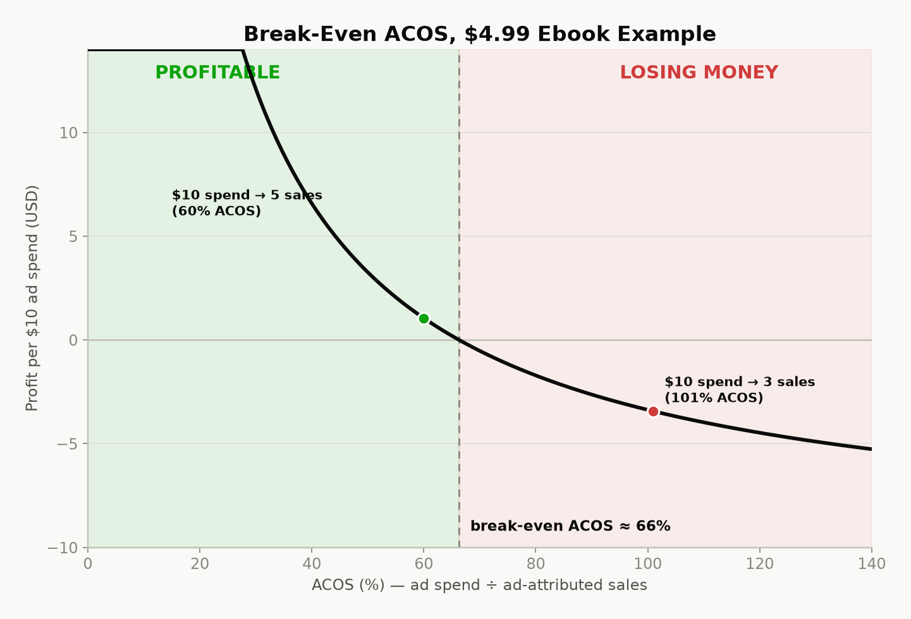
Figure 10.2 — The break-even line for the $4.99 example above. Below the line, an ad is paying for itself before any read-through, page-read income, or brand-visibility effect is even counted; above it, the ad is a net cost you’re choosing to pay for exposure, which can still be a reasonable choice during a launch, as long as you’re making that trade on purpose.
Two caveats worth holding onto: direct ACOS profitability isn’t the whole picture. A break-even-or-slightly-negative ad during launch week can still be worth running for the visibility and momentum effects described in Chapter 9, as a deliberate, bounded spend — the danger is treating every ad that way indefinitely, rather than as a specific, time-limited choice. And a single sale can undercount a book’s real return if it’s part of a series — factor a reasonable estimate of read-through into subsequent volumes before writing off a campaign that looks marginal on book one alone.

Budget discipline for a new advertiser
- Start with a small daily budget and let a campaign run long enough to gather a meaningful number of clicks before judging it — a campaign killed after two days rarely has enough data to mean anything.
- Read the Search Term Report, not just the campaign-level ACOS — it’s common for one converting phrase to be subsidizing several non-converting ones sitting in the same auto campaign.
- Add non-converting search terms as negative keywords once they’ve had enough clicks with zero sales to be a real signal, not a fluke — this stops you paying repeatedly for traffic that’s already shown you it doesn’t convert.
- Revisit bids and budgets weekly, not daily — day-to-day noise in a small campaign’s numbers is mostly randomness, not signal.

Part IV — The Business Side

Chapter 11: Getting Paid: Taxes, Payments, and Reporting
The most common reason a new author’s first royalty payment is delayed or smaller than expected has nothing to do with sales — it’s an incomplete tax interview. This chapter is the unglamorous plumbing that makes sure the money your earlier chapters worked to earn actually reaches you, at the rate it’s supposed to.

The tax interview isn’t optional paperwork — it sets your withholding rate
Before KDP releases any royalty, it requires a tax interview, completed in your account settings:
- US persons complete a Form W-9.
- Non-US individuals complete a Form W-8BEN.
- Non-US entities (a company rather than an individual) complete a Form W-8BEN-E.
Here is the part that catches people off guard: royalties are US-source income for tax purposes, and the default US withholding rate on that income for a non-US person is 30%, taken straight off the top before you ever see it. Many countries have a tax treaty with the United States that reduces or eliminates this withholding on royalty income specifically — but that reduced rate is not automatic. To claim it, your W-8BEN needs a foreign taxpayer identification number and an explicit treaty claim referencing the relevant treaty article. Skip that step, even by accident, and you default to the full 30% withholding regardless of what your country’s treaty actually allows.
Key takeaway: Treaty rates and eligibility genuinely vary by country and change over time — this book won’t guess a number for your specific situation. Look up your country’s current entry in the US Tax Treaty tables (or ask an accountant who handles cross-border royalty income) before your first sale, get whatever foreign tax ID the treaty claim requires, and complete the W-8BEN correctly the first time. Fixing an incorrect tax interview after the fact is entirely possible but slower than doing it right before you need it.
If a required taxpayer ID takes time to obtain in your country, start that process as early as possible — ideally before you expect your first payment — rather than discovering the delay when a payment is already held up.

How and when you’re actually paid
KDP pays royalties by direct deposit (or check, where direct deposit isn’t available for your country/currency), roughly 60 days after the month in which the royalty was earned closes — a February sale is typically paid around the end of April, not immediately. Payment also requires your accumulated royalty balance to clear a minimum threshold, which varies by currency and payment method; check your own Payment settings inside KDP for the current number rather than relying on a fixed figure here, since these thresholds are exactly the kind of detail that changes without much announcement.

Reading your reports without confusing yourself
KDP gives you three different views of your own money, and new authors frequently compare the wrong two against each other:
- Sales Dashboard — near-real-time, estimated units and royalties. Useful for watching a launch unfold; not the final number.
- Prior Months’ Royalties report — the finalized figures for a closed month, after returns and any KENP fund rate is set. This is the number that will actually match what gets paid.
- Payments report — the actual disbursements made to your bank account, which lag the royalty-earned month by the ~60-day delay above.
Expect the Sales Dashboard’s running estimate and the eventual finalized monthly report to differ slightly — that’s normal, not an error, and it’s exactly why the finalized report, not the live dashboard, is the number to use for any real accounting.

Treat it like the business it is
Once money is actually moving, a little bookkeeping discipline pays for itself: keep records of every business expense (editing, cover design, ads, any software or service subscriptions) against your royalty income, and consider a dedicated bank account once revenue is more than trivial, purely to keep the paper trail clean. Whether self-published royalty income counts as self-employment income or passive royalty income for tax purposes is a real, fact-specific question in a number of jurisdictions — it typically depends on how regularly and actively you’re engaged in the business of writing and publishing, not just on the fact that “royalty” is in the name — and it materially affects which expenses are deductible and whether self-employment-type tax applies. This is exactly the kind of question worth a genuine conversation with an accountant familiar with creative or royalty income once you’re earning enough for the distinction to matter, rather than a guess from a general-purpose guide like this one.

Chapter 12: KDP Select vs. Going Wide
Once a book is written, formatted, priced, and ready to launch, you face one more structural decision: does the ebook live on Amazon exclusively, or everywhere at once? Neither answer is universally correct, and the honest version of this chapter is that it depends heavily on your genre and your specific readers.

What Select actually asks for, and what it gives back
Enrolling an ebook in KDP Select commits it to a rolling 90-day exclusivity period: for that ebook edition specifically, it can only be sold as an ebook through Amazon — not Apple Books, Kobo, or anywhere else. This restriction applies to the digital edition only; a paperback or hardcover edition of the same book is entirely unaffected and can be sold anywhere regardless of your Select enrollment. In exchange, Select unlocks:
- Kindle Unlimited / Kindle Owners’ Lending Library page-read income (Chapter 2’s KENP mechanics) — for some genres, this is not a minor bonus but the majority of total revenue.
- Free Book Promotions — a limited number of days where the book can be offered free directly on Amazon, useful for a launch push, a series first-volume strategy (Chapter 8), or reviving a quiet backlist title.
At the end of each 90-day term, Select auto-renews unless you opt out — worth calendaring, so a decision to go wide doesn’t get delayed by simply forgetting the renewal date exists.

What “going wide” gets you instead
Going wide means distributing the ebook to multiple retailers and library platforms — Apple Books, Kobo, Barnes & Noble, Google Play Books, and library-lending systems — either by uploading to each directly or, far more commonly, through an aggregator like Draft2Digital or PublishDrive, which handles the individual retailer relationships for a cut of sales made through it. The upside is real: your income isn’t dependent on one platform’s rules, algorithm changes, or payment terms, and some readerships (certain nonfiction niches especially) skew more heavily toward Apple or library reading than Amazon’s fiction-heavy Kindle Unlimited subscriber base does.
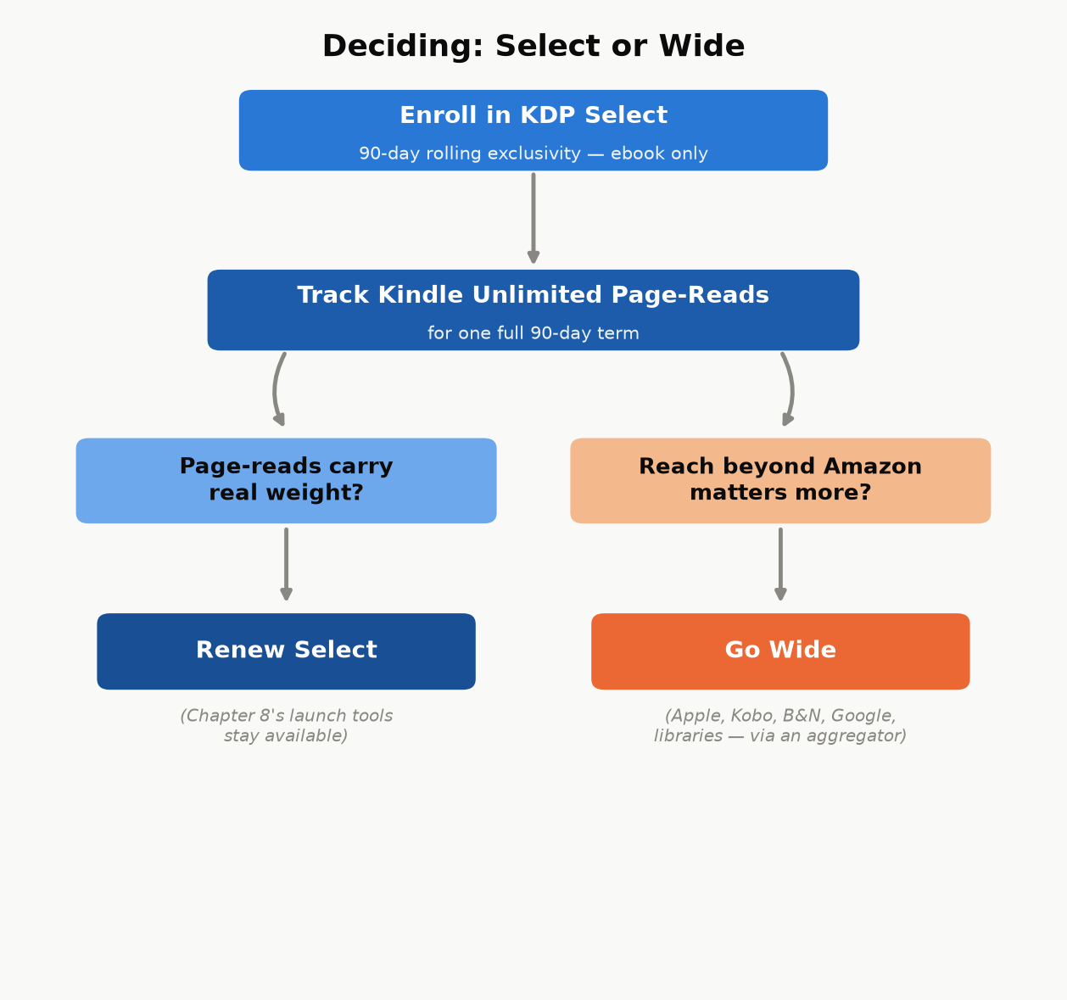
Figure 12.1 — Not a one-time choice: run one real 90-day term, then let what actually happened to your page-reads make the next decision instead of a genre-wide generalization.

Choosing without guessing
A reasonable default for a new author with no existing data: enroll the first book (or series) in Select for one 90-day term, watch the actual page-read numbers against what wide distribution would plausibly have earned, and make the next term’s decision from real data instead of a genre-wide generalization. Kindle Unlimited tends to matter most for genres with heavy series readers who consume books quickly (romance, fantasy, thriller fiction, in particular) and matters less for many nonfiction categories, where a reader may buy once rather than subscribe-and-binge — but “tends to” is not a guarantee for your specific book, which is exactly why testing one real term beats assuming either way.

Chapter 13: Avoiding the Traps
Every mechanism described in this book so far is free, documented, and available to any KDP account. Everything in this chapter exists because that fact — self-publishing costs nothing but effort — is exactly what a whole ecosystem of scams, shortcuts, and account-ending mistakes is built to obscure. Knowing what this chapter covers is often the difference between a first-time author who keeps their account and their earnings, and one who doesn’t.

Vanity and predatory hybrid publishers
The scam is almost always the same shape: a company charges a new author a fee — anywhere from a few hundred to many thousands of dollars — for services that either cost nothing (an ISBN assignment, a KDP upload, basic ebook formatting) or cost a small fraction of what’s being charged (professional cover design, a real developmental edit). Watch for:
- Unsolicited contact — “we read your manuscript and think it has real potential” from a company you never submitted to. Legitimate publishers don’t cold-call unpublished manuscripts they found on their own.
- Upfront fees framed as necessary for basic access to distribution that KDP already provides for free.
- Vague, inflated promises — “bestseller,” “bookstore placement,” “Hollywood option potential” — offered with no specifics about how, paired with pressure to sign quickly.
None of this means every paid publishing-adjacent service is a scam — freelance editors, cover designers, and formatters described in earlier chapters are legitimate paid services doing real, specific work. The distinguishing question is always the same: can you name, specifically, what this fee is paying for, and could you get that same specific thing done elsewhere for less? A legitimate freelancer answers that question instantly. A predatory hybrid publisher’s answer is deliberately vague.

Fake reviews and rank manipulation
Buying reviews, joining a review-swap ring, or paying for a “guaranteed ranking boost” service are all violations of Amazon’s content policies, and the consequence isn’t limited to the one book involved — Amazon can suspend an entire account over manipulated reviews or rank manipulation, which means every book you’ve ever published under that account stops earning at once, not just the one that triggered it. There is no version of this trade-off that’s worth it: the honest ARC-team approach from Chapter 9 achieves the same “reviews at launch” goal legitimately, with none of the downside risk.

AI-content flooding
A different, newer version of the same underlying trap: mass-producing large numbers of thin, minimally reviewed, AI-generated books to flood categories, hoping volume compensates for quality. Amazon has been actively tightening enforcement against exactly this pattern — content-quality policies, required AI-content disclosure (Chapter 4), and account-level publishing limits for accounts that trip its low-quality signals. Beyond the policy risk, it’s a reputation trap for your author name and your existing titles: a flood of low-effort books under one name damages trust in your better books too, in a marketplace where a reader’s next click is often “see all books by this author.”

Copyright and licensing traps
Two mistakes show up often enough to name directly: assuming something is public domain when it isn’t (public-domain status depends on specific publication dates and jurisdictions, and a translation, annotation, or edited edition of a public-domain work can itself carry separate copyright even when the underlying original doesn’t), and using images — cover art, interior illustrations — without a license that actually covers commercial use. A stock image licensed for personal or editorial use is not automatically licensed for a book you’re selling; check the specific license terms every time, for every image, not just the ones that look obviously professional.
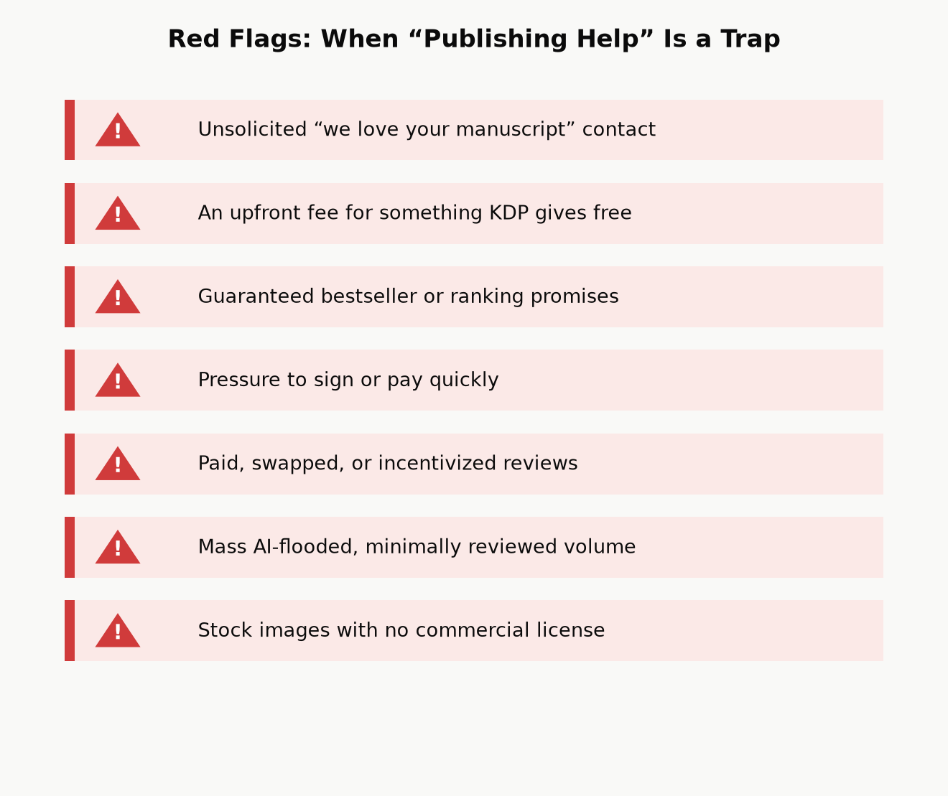
Figure 13.1 — The common thread across every trap above: a shortcut that trades a small, certain cost now (an editor’s fee, a slower honest launch) against a large, uncertain cost later (a suspended account, a damaged reputation, a copyright claim) — and the trade almost never pays off in your favor.

The best filter: check KDP’s own help pages first
A large share of “secret” paid courses promising to reveal how self-publishing really works are, on close inspection, reselling information KDP already publishes for free in its own Help pages and this book’s chapters. Before paying for any course or service that claims special insider knowledge of “the algorithm” or “what really works,” spend twenty minutes checking whether the claim is actually just documented KDP policy with a markup attached. Often, it is.

Part V — Playing the Long Game

Chapter 14: From One Book to a Catalog
Every chapter so far has been about one book. This chapter is about the point at which the math changes: a catalog of several related books doesn’t just add up its individual books’ income — it compounds, because each additional title increases the discoverability surface of every title already in the catalog, not just its own.

Why a catalog outearns the sum of its books
A reader who finishes your first book is shown your other books directly, on your Amazon author page, on each book’s “more by this author” section, and through “customers also bought” placements — at zero additional marketing cost, because you already paid the one-time cost (writing it, formatting it, launching it) to acquire that reader’s attention in the first place. A five-book catalog isn’t five separate customer-acquisition problems; it’s one customer-acquisition problem (get a reader to try book one) followed by four essentially free upsells. This is the same read-through economics from Chapter 3, extended from a single series to an entire body of work.
There’s a second, quieter compounding effect: the fixed costs of learning this whole system are paid once. The time spent learning to navigate KDP’s upload flow, understanding your own ad account well enough to run a profitable campaign, developing a cover style that reads correctly for your category, building an ARC team and an email list — none of that resets to zero for book two. Book two of a well-run catalog typically takes meaningfully less total effort to launch than book one did, for the simple reason that most of that effort was fixed-cost learning, not per-book labor.
Case study: planning for compounding from day one. Elsewhere in this same catalog, a technical nonfiction series was planned from the start as 21 books, one per topic tier, rather than as a single giant volume — explicitly so that each finished book would immediately extend the discoverability and “more by this author” surface of every other book already published, instead of asking one enormous, slow-to-finish book to carry the entire catalog’s earning potential alone. The same author’s broader catalog spans several genuinely different categories at once — a technical engineering series, a work of narrative popular history, an illustrated science series for younger readers, a mathematics series — which spreads risk the same way a diversified small-business portfolio does: a slow month or an algorithm change affecting one category doesn’t take down income from the others at the same time. Neither choice — many small books in one series, or several unrelated catalogs at once — is the “correct” one in isolation; both are the same underlying principle (a catalog compounds; a single book doesn’t) applied to two different situations.
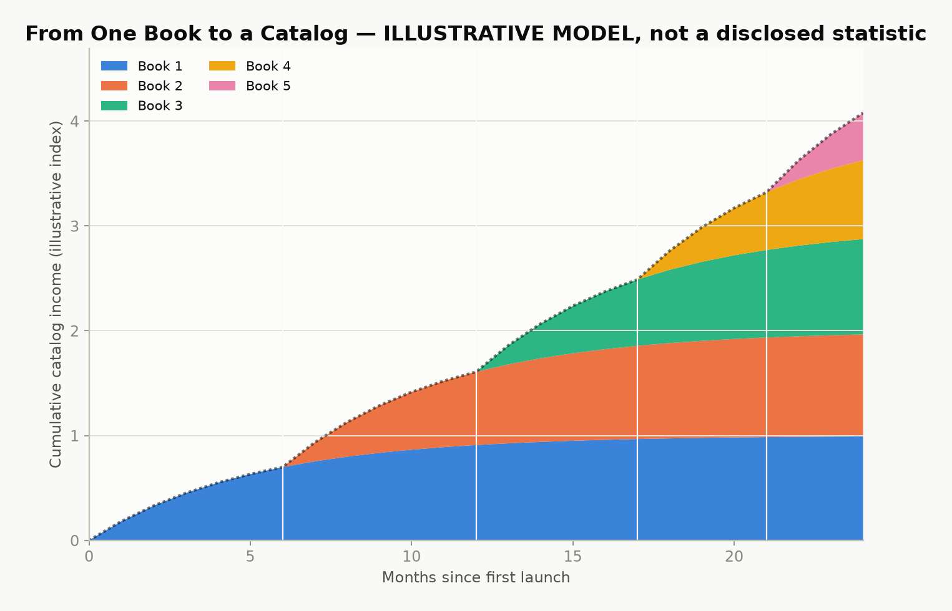
Figure 14.1 — Illustrative model, not a disclosed statistic: cumulative catalog income over time as each new book adds both its own sales and a cross-sell boost to every earlier title. The compounding shape is the real lesson — a real catalog’s actual curve depends entirely on genre, quality, and consistency of output.

Bundles and an owned audience
Two more tools extend a catalog’s earning power beyond individual book sales:
- Box sets and bundles. Combining several existing books into one discounted bundle product creates a new, sellable item with close to zero additional creation cost — the content already exists — while giving price-sensitive readers and new-to-you browsers a lower-friction way to try several books at once.
- An email list, built from a simple sign-up offer (a short bonus chapter, a checklist, a free related short work) placed inside your existing books’ back matter. A list of genuinely interested readers is a source of concentrated launch-day velocity (Chapter 9) that you control directly, rather than one that depends entirely on Amazon’s algorithms, ad auctions, or luck — the single most durable hedge against any one platform changing its rules on you.

A second format, mostly for free: audiobooks
There’s a third format beyond ebook and print, and it extends a catalog the same way bundles and an email list do: almost all of its cost is paid once, against content that already exists. ACX (Audiobook Creation Exchange) is Amazon’s audiobook platform, producing for Audible, Amazon, and iTunes from one submission — the audio equivalent of KDP itself.
Three ways to get a finished audiobook, at three very different price points:
- Narrate it yourself. Zero cost beyond your own time and reasonably decent recording equipment. A real option for nonfiction in particular, if the author has a clear, listenable voice — readers of a how-to guide are often buying the author’s judgment as much as the words, and hearing it in their own voice is not a downgrade.
- Royalty share with a narrator. No upfront cash — the narrator is paid out of future royalties instead of a fee, typically splitting close to evenly with the rights holder. This is the standard route for an author with no production budget but a book (or catalog) with a real chance of actually selling, since a narrator taking a royalty-share deal is, in effect, betting on the book too.
- Pay-per-finished-hour (PFH). A professional narrator, paid a flat fee for each finished hour of audio — commonly several hundred dollars per hour, which puts a full-length audiobook’s upfront cost in the low-to-mid thousands. You keep the full royalty going forward; you also carry the entire financial risk if the audiobook doesn’t earn it back.
A newer, fourth option: Amazon has been rolling out AI-narrated (“Virtual Voice”) audiobooks directly through KDP for eligible titles, at little to no cost — a real, current alternative to the three routes above for an author testing whether their book’s audience wants audio at all before committing real money to it. Eligibility, available voices, and quality have been moving targets since this feature launched; check your own KDP dashboard for what’s actually offered before assuming it works the way an older article describes.
Worked example. A pay-per-finished-hour audiobook running 6 finished hours at $300/hour costs $1,800 upfront, fully owned by the author afterward. The same book via royalty share costs $0 upfront, but every future audiobook royalty is split with the narrator, indefinitely. Neither choice is simply “better” — PFH is the better bet for a book with proven sales already (Chapters 2 and 15 show you how to tell); royalty share is the better bet for a first audiobook on an unproven title, since it caps the downside at zero.
Exclusivity works the same trade-off shape as KDP Select (Chapter 12): ACX offers a meaningfully higher royalty rate for audiobooks distributed exclusively through Audible, Amazon, and iTunes, against a lower rate for non-exclusive distribution that also reaches other audiobook retailers and library platforms. Check ACX’s current royalty table before committing — like every rate in this book, it’s a real number that changes over time, not a fixed constant.
Not every book belongs in audio. A book that leans on charts, worked numerical examples, or anything the reader needs to see translates poorly to a listen-only format — this book’s own royalty-cliff chart and break-even ACOS math, read aloud with no image to look at, would be a worse experience than the page version, not an equal one. A narrative nonfiction book, a memoir, or a novel has no such problem. Know which kind of book you’ve written before assuming audio is the obvious next format.

Chapter 15: A Realistic First-Year Plan
This book opened with a promise to show its arithmetic, including the unflattering parts. Here is the unflattering part: self-publishing income is a power law, not a bell curve. A small share of books and authors earn very well; a large share earn modestly or barely cover their production costs; very few outcomes land neatly in between. Nothing in this book changes that distribution — what it changes is your odds of landing in the better half of it, by doing the specific, checkable things (real editing, honest launch coordination, correct categories and keywords, disciplined ad spending, a catalog instead of a single bet) that separate a professionally run small business from a hopeful one-off.
Key takeaway: Treat your first book as tuition, not a lottery ticket. Its most valuable output may not be its own royalty check — it may be everything you learn about your category, your readers, and your own process, which book two then gets to apply at a fraction of the effort. That’s not a consolation prize; it’s exactly how the compounding in Chapter 14 gets started.

A month-by-month shape for a first book
Every catalog’s real timeline will vary, but a reasonable default shape, tying every earlier chapter together:
- Months 1–2 — Write and research (Chapters 1, 3). Confirm the category and audience against real Amazon signals before finishing the draft, not after.
- Month 3 — Revise, design, recruit (Chapters 4, 6, 9). Run your editing passes, commission or finalize the cover, and open ARC-team recruitment early enough for readers to actually finish the book before launch.
- Month 4 — Format, list, launch (Chapters 5, 7, 8, 9). Format for the correct output(s), set categories and keywords deliberately, price with intent, and concentrate your launch-week activity rather than spreading it thin.
- Months 5–6 — Read the data, adjust, decide on ads (Chapters 10, 11, 12). Start (or continue) advertising with real break-even math, read your first finalized royalty report rather than the running estimate, and make your first informed KDP Select renewal decision from actual page-read numbers.
- Months 7–12 — Start the next book, with everything you now know (Chapters 3, 14). Apply the category and audience research to book two (or book one of your next series) with the fixed-cost learning from this round already paid off, and begin building the email list and bundle options that only make sense once more than one book exists.
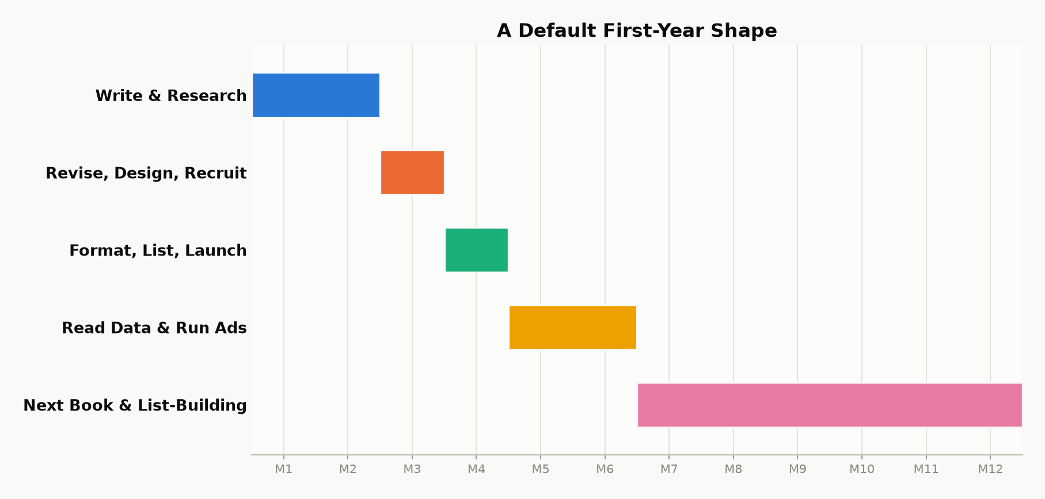
Figure 15.1 — A default first-year shape. The exact pace will stretch or compress around real life — the sequence (research before writing, editing before launch, data before the next big decision) matters more than hitting these specific months.
Whatever your book earns in its first year, the honest measure of whether this was worth doing isn’t that first royalty number in isolation — it’s whether you finished the year with a repeatable process and a second book underway. That’s the entire difference between having self-published a book, and having become a self-publisher.

Appendix A — The One-Page Launch Checklist
Manuscript
☐ Developmental, line, copy, and proofread passes complete (Chapter 4)
☐ At least one pass done by someone other than you
☐ Every number and cross-reference checked
Format
☐ Ebook: real Heading 1/2 styles used throughout; no page-numbered TOC; no index (Chapter 5)
☐ Print: page numbers, running headers, correct trim size and margins; spine width from KDP’s calculator, not hand-calculated (Chapter 5)
☐ Checked in KDP’s online previewer on more than one device size
☐ Physical proof ordered and read, for any print edition
Cover
☐ Passes the thumbnail test at actual small size (Chapter 6)
☐ Matches genre/category conventions on purpose, not by accident
☐ Title readable, one clear focal point
Metadata
☐ All seven backend keyword slots used, as full phrases, none repeating title/subtitle words (Chapter 7)
☐ Most specific honest category chosen in all three slots; additional categories requested from KDP support if a better fit exists outside the picker (Chapter 7)
☐ Price set deliberately inside (or intentionally outside) the 70% band, not by default (Chapter 8)
Compliance
☐ Tax interview (W-9 / W-8BEN / W-8BEN-E) completed and correct (Chapter 11)
☐ AI-content disclosure answered honestly, if applicable (Chapter 4)
☐ KDP Select enrollment decided on purpose, not left on autopilot (Chapter 12)
Launch
☐ ARC team recruited, copies out with enough lead time to finish reading
☐ Reviews and personal-network purchases coordinated to land at/near launch, not trickled (Chapter 9)
☐ Ad campaign (auto, small budget) ready to start on launch day, if using one (Chapter 10)

Appendix B — Royalty Quick Reference
Ebook
70% royalty band: list price $2.99–$9.99 (US), minus a delivery fee (~$0.15 per MB of file size)
35% royalty: any price outside that band ($0.99–$200), no delivery fee subtracted
Kindle Unlimited / KOLL: paid per KENPC page read, from a shared monthly fund; rate varies month to month (historically roughly $0.004–$0.005/page) — check your Reports dashboard for the actual current rate
Print
Paperback (Amazon channel): 60% of list price, minus printing cost
Paperback (expanded distribution): 40% of list price, minus printing cost
Hardcover (Amazon channel): 60% of list price, minus printing cost
Printing cost depends on page count, trim size, ink (B&W vs. color), and paper choice — always confirm with KDP’s own price calculator before setting a list price
The one formula worth memorizing
Break-even ACOS ≈ Royalty per copy ÷ Sale price × 100%

Appendix C — ISBNs, Wide Distribution, and Further Reading

ISBNs
A Kindle ebook needs no ISBN at all — it’s identified by its Amazon-assigned ASIN instead. A paperback or hardcover does need one, and KDP will assign a free KDP ISBN automatically if you don’t provide your own. The trade-off: a free KDP ISBN lists KDP as the book’s publisher of record and ties that specific ISBN to Amazon’s own print service. Buying your own ISBN (from Bowker in the US, or your country’s national ISBN agency elsewhere) costs money but lists you as the publisher of record and gives you the freedom to move the same edition to a different print provider later without changing its identifying number. For a book staying on KDP print indefinitely, the free ISBN is a perfectly reasonable choice; for a book where you specifically want to be recorded as your own imprint, or expect to need print-provider flexibility, buying your own is worth the cost.

Wide distribution tools
For authors choosing to go wide (Chapter 12) rather than enroll in KDP Select, common legitimate routes include distributing directly to individual retailers (Apple Books, Kobo, Barnes & Noble Press) or through an aggregator that handles multiple retailers and library platforms from a single upload — Draft2Digital and PublishDrive are widely used examples. For wider print distribution into bookstores and libraries beyond KDP’s own expanded distribution option, IngramSpark is the most commonly used print-on-demand and distribution service in the indie-publishing space.

Further reading and legitimate resources
- KDP’s own Help pages and KDP University — the single best free, authoritative, continuously updated source for exact current policies, price bands, and thresholds. When any number in this book conflicts with what KDP’s own pages currently say, trust KDP’s pages — this book’s arithmetic will still be correct, but specific figures (delivery fee rates, payment thresholds, category lists) are exactly the kind of detail that changes over time.
- Author communities built around self-publishing craft and business (genre-specific writing organizations, indie-author forums and groups) are a good source of current, lived experience — read them the same way Chapter 13 recommends reading anything: with an eye for whether a claim is documented policy or someone’s unverified theory about “the algorithm.”
- A tax professional familiar with royalty or self-employment income, for the specific questions Chapter 11 deliberately declined to answer in general terms.

A Closing Word
Nothing in this book is complicated on its own. Royalty math is arithmetic. Keyword slots are a form field. A launch is a calendar with the same events moved closer together. What makes self-publishing hard isn’t any individual step — it’s that all fifteen chapters’ worth of steps land on one person, and it’s tempting to skip the unglamorous ones (a real editing pass, an honest category choice, the tax interview) in favor of the exciting one (hitting publish).
The authors who make good money at this aren’t the ones who found a secret Amazon doesn’t want you to know. They’re the ones who did the plain, checkable, occasionally tedious work in every chapter of this book, on purpose, in order, and then did it again for the next book — because by the second time, most of it was already fixed cost, paid off. That’s the whole secret, and it was never actually a secret. Go write something worth finding.

